**ADVANCING COSMETIC INNOVATIONS THROUGH ORGANIC BIOMASS: A WEB APPLICATION FOR EFFICIENT BIOMASS CONVERSION INTO SUSTAINABLE FORMULATIONS**

**A PROJECT REPORT**

**Submitted** **By**

**MADHESHWARAN M (912321104019)**

**RAMACHANDRAN V (912321104036)**

**VISHWA M (912321104053)**

***in partial fulfilment for the award of the degree***

***of***

**BACHELOR OF ENGINEERING**

***in***

**COMPUTER SCIENCE AND ENGINEERING**



**SACS MAVMM ENGINEERING COLLEGE, MADURAI**



**ANNA UNIVERSITY: CHENNAI 600025**

**MAY 2025  
I**

**ANNA UNIVERSITY: CHENNAI 600025**

**BONAFIDE CERTIFICATE**

Certified that this project report, **ADVANCING COSMETIC INNOVATIONS THROUGH ORGANIC BIOMASS: A WEB APPLICATION FOR EFFICIENT BIOMASS CONVERSION INTO SUSTAINABLE FORMULATIONS,**

is thebona fide work of **MADHESHWARAN M (912321104019), RAMACHANDRAN V (912321104036), and VISHWAM (912321104053),** who carried out the project work under my supervision.

|  |  |
| --- | --- |
| **SIGNATURE** | **SIGNATURE** |
| **Mrs. M. SIVABALASUNDARI, M.E.,** | **Mrs. A JUDITH AROCKIA GLADIES, M.E.,**  **SUPERVISOR** |
| **HEAD OF THE DEPARTMENT** | **ASSISTANT PROFESSOR** |
| Computer Science and Engineering | Computer Science and Engineering |
| SACS MAVMM Engineering College | SACS MAVMM Engineering College |
| ALAGARKOVIL | ALAGARKOVIL |
| MADURAI -625301 | MADURAI -625301 |

Submitted for the viva-voce in B.E degree held on___________________

**INTERNAL EXAMINER EXTERNAL EXAMINAR**

**II**

**ACKNOWLEDGEMENT**

At first, I would like to thank my **PARENTS** & **WELL-WISHERS** for their unwavering support and giving opportunity to complete my project.

I take great pleasure in expressing my sincere thanks to the energetic, kind-hearted, ever encouraging and beloved general secretary **Mr. G. GANESAN,** for the moral support.

I would like to express my sincere thanks to our honourable principal

**Dr. S. NAVANEETHA KRISHNAN., M.E., Ph.D.,** for his immense help in completing my project.

I express my gratitude to **Mrs. M. SIVABALASUNDARI, AP/CSE, HEAD OF THE DEPARTMENT OF COMPUTER SCIENCE AND ENGINEERING,** SACS MAVMM Engineering College, Madurai, for her continuous support and encouragement throughout this project.

I express my sincere thanks to my guide **Mrs. A JUDITH AROCKIA GLADIES ASSISTANT PROFESSOR OF COMPUTER SCIENCE AND ENGINEERING,** SACS MAVMM Engineering College, Madurai, for her valuable inputs and guidance, encouragement, wholehearted co-operation and constructive criticism throughout the duration of the project. I take opportunity to thank all our department lectures who directly or indirectly helped our project. Finally, I thank my friends for their support.

MADHESHWARAN M

RAMACHANDRAN V

VISHWA M

**III**

**ABSTRACT**

This project focuses on developing a web application that helps manage hair waste and transforms it into useful beauty and hair care products. Salons generate a significant amount of hair waste, which often ends up in landfills, causing environmental pollution. Our system provides a digital platform for salon owners and clients to track and process hair waste efficiently, ensuring a more sustainable and eco-friendly approach. The web application is designed with a user-friendly interface that allows salons to log hair waste collection, monitor its processing, and analyze its quality based on melanin and keratin levels. Melanin plays a crucial role in UV protection, while keratin strengthens hair care products. These two components are essential in the production of beauty items, making their extraction and processing highly valuable. By implementing machine learning techniques, the system ensures that the best processing method is chosen, optimizing the extraction process and enhancing product quality. Additionally, the web application facilitates better communication between salons and manufacturers, allowing for smoother transactions and real-time tracking of hair waste management. The system also generates detailed reports that provide insights into waste collection, processing efficiency, and overall impact on sustainability. This feature helps salon owners make informed decisions and adopt more environmentally friendly practices. By using this web application, salons can significantly reduce waste, contribute to a greener environment, and promote sustainability in the beauty industry. The project aims to bridge the gap between waste management and technological advancements, ensuring that hair waste is effectively repurposed rather than discarded. Future improvements of this project include refining the hair extraction process, scaling up production to accommodate more salons, and expanding the application’s functionalities. To improve decision-making and efficiency, the system utilizes a decision tree algorithm. This algorithm helps in selecting the best quality hair for different beauty and hair care products by analyzing data such as hair type, temperature treatment, and melanin-keratin content. This initiative holds great promise in revolutionizing salon waste management and integrating technology into the beauty industry for a more sustainable future.

**IV**

|  |  |  |
| --- | --- | --- |
| **TABLE OF CONTENTS** | | |
| **CHAPTER NO.** | **TITLE** | **PAGE NO.** |
|  | **ABSTRACT** | IV |
|  | **LIST OF FIGURES** | VIII |
|  | **LIST OF SYMBOLS** | IX |
| **1** | **INTRODUCTION** | 1 |
| * 1. OVERVIEW | 1 |
| * 1. PURPOSE OF THE PROJECT | 1 |
| * 1. LITERATURE REVIEW | 2 |
| **2** | **SYSTEM ANALYSIS** | 3 |
| * 1. INTRODUCTION | 3 |
| * 1. ANALYSIS MODEL | 3 |
| * 1. SDLC PHASES | 4 |
| * 1. HARDWARE & SOFTWARE   REQUIRMENT | 6 |
| * 1. INPUT AND OUTPUT | 6 |
| * 1. LIMITATIONS | 7 |
| * 1. EXISTING STSTEM | 7 |
| * 1. PROPOSED SYSTEM | 8 |
| **3** | **FEASIBILITY REPORT** | 9 |
| * 1. TECHNICAL FEASIBILITY | 9 |
| * 1. OPERATIONAL FEASIBILITY | 9 |
| * 1. ECONOMIC FEASIBILITY | 10 |

**V**

|  |  |  |
| --- | --- | --- |
| **4** | **SOFTWARE REQUIREMENT SPECIFICATIONS** | 11 |
| * 1. FUNCTIONAL REQUIREMENTS | 11 |
| * 1. NON-FUNCTIONAL REQUIREMENTS | 12 |
| * 1. PERFORMANCE REQUIREMENTS | 13 |
| **5** | **SYSTEM DOVELOPEMENT ENVIRONMENT** | 14 |
| * 1. INTRODUCTION TO JAVA | 14 |
| * 1. SERVLETS, JSP | 17 |
| * 1. JDBC | 27 |
| * 1. HTML, JAVASCRIPT | 30 |
| * 1. FRAMEWORKS | 32 |
| **6** | **SYSTEM DESIGN** | 33 |
| * 1. INTRODUCTION | 33 |
| * 1. SYSTEM ARCHITECTURE | 36 |
| * 1. E-R DIAGRAM | 37 |
| * 1. FLOW DIAGRAM | 38 |
| * 1. DFD SYMBOLS | 39 |
| * 1. USE CASE DIAGRAM | 44 |
| 6.7. CLASS DIAGRAM | 45 |
| **7** | **SYSTEM TESTING AND IMPLEMENTATION** | 46 |
| * 1. . INTRODUCTION | 46 |
| 7.2. SOFTWARE TESTING | 46 |
| 7.3. TESTING PROCEDURES | 47 |

**VI**

|  |  |  |
| --- | --- | --- |
| **8** | **SYSTEM SECURITY** | 50 |
| 8.1. INTRODUCTION | 50 |
| 8.2. SECURITY IN SOFTWARE | 51 |
| **9** | **CONCLUTION** | 53 |
| **FUTURE ENHANCEMENT** | 54 |
| **APPENDIX 1.1** | 55 |
| **APPENDIX 1.2** | 61 |
| **CONFERENCE CERTIFICATE** | 68 |
| **REFERENCE** | 69 |

**VII**

|  |  |  |  |
| --- | --- | --- | --- |
| **LIST OF FIGURES** | | | |
| **S.NO.** | **FIGURE NO.** | **DESCRIPTION OF FIGURE** | **PAGE NO.** |
| 1 | 6.2 | SYSTEM ARCHITECTURE | 36 |
| 2 | 6.3 | E-R DIAGRAM | 37 |
| 3 | 6.4 | FLOW DIAGRAM | 38 |
| 4 | 6.5 | DFD SYMBOLS | 39 |
| 5 | 6.6 | USE CASE DIAGRAM | 43 |
| 6 | 6.7 | CLASS DIAGRAM | 44 |

**VIII**

|  |  |
| --- | --- |
| **LIST OF ABBREVIATION** | |
| ML | * Machine Learning |
| AI | * Artificial Intelligence |
| DB | * Database |
| API | * Application Programming Interface |
| UI | * User Interface |
| UX | * User experience |
| BI | * Business Intelligence |
| CSV | * Comma-Separated Value |
| B2B | * Business to Business |
| IOT | * Internet of things |
| KPI | * Key Performance Indicator |
| R&D | * Research and Development |
| UV | * Ultraviolet |
| HPLC | * High-Performance Liquid Chromatography |
| SDG | * Sustainable Development Goals |

**IX**

**CHAPTER-1**

**INTRODUTION**

* 1. **OVERVIEW**

The **Keratin Management Project** is an innovative initiative that addresses two key challenges in the salon industry: reducing hair waste and enhancing hair care product efficacy. It aims to repurpose waste human hair into engineered beauty products, promoting both environmental sustainability and technological advancement. Human hair contains **melanin** and **keratin**, vital biomolecules that contribute to color, UV protection, and hair strength. The project uses **advanced extraction methods**, including ionic liquids, to isolate and preserve these components effectively. It ensures high product quality by analyzing melanin and keratin under different conditions. Additionally, **decision tree algorithms** are used to optimize the extraction process and product development. This data-driven approach supports personalized solutions for diverse hair types. The platform fosters efficient collaboration between salons and manufacturers. Looking ahead, the project plans to scale operations and explore new applications. Ultimately, it promotes a more **sustainable and effective beauty industry**.

* 1. **PURPOSE OF THE PROJECT**

The project significantly contributes to environmental sustainability by transforming salon hair waste into valuable products, thereby reducing the amount of waste that ends up in landfills or is incinerated. This process helps lower pollution levels and minimizes the harmful environmental impact of traditional disposal methods. Additionally, it reduces greenhouse gas emissions commonly associated with conventional sunscreen production, offering an eco-friendlier alternative. By extracting melanin from hair, the project provides a natural source of UV protection, which can replace chemical UV filters that may pose health risks. Beyond environmental benefits, the initiative also supports local communities by involving salons in the hair collection process, fostering partnerships and creating new economic opportunities at the grassroots level.

**1**

* 1. **LITERATURE REVIEW**

[1] **“Communication-efficient learning of deep networks from decentralized** **Data”**

The paper focuses on making deep learning more communication-efficient when training on decentralized data. It addresses challenges in federated learning, where data is distributed across multiple devices. By reducing communication overhead, the model becomes scalable and faster. Techniques like model compression and selective updates are explored. This approach is crucial for real-world applications involving edge devices and privacy-sensitive environments.

[2] **“Federated learning of predictive models from federated** **electronic health records”**

This study explores federated learning to build predictive models from decentralized electronic health records (EHRs). It allows hospitals and clinics to collaboratively train models without sharing patient data, preserving privacy. The approach handles data heterogeneity across institutions. By leveraging federated learning, accurate models can be trained while maintaining compliance with data protection laws. This is a major advancement in healthcare AI and secure data use.

[3] **“Federated learning** **in smart city sensing: Challenges and opportunities”**

Federated learning in smart city sensing enables data-driven insights without compromising privacy. By allowing edge devices like sensors and cameras to train models locally, it reduces the need to transmit sensitive data. This approach addresses key challenges like data heterogeneity, latency, and bandwidth constraints. Opportunities include real-time traffic monitoring, pollution tracking, and energy optimization. Overall, federated learning enhances urban intelligence while ensuring data security.

[4] **“Advances and open problems in federated learning”**

Federated learning has seen rapid advances in enabling privacy-preserving machine learning across decentralized data sources. It supports model training without sharing raw data, protecting user confidentiality. Key achievements include improved communication efficiency and personalized models.

**2**

**CHAPTER – 2**

**SYSTEM ANALYSIS**

**2.1 INTRODUTION**

The Keratin Management Project is an innovative initiative in the beauty and salon industry that focuses on sustainability and technological advancement. It aims to create high-quality hair care products from waste human hair, reducing salon waste and environmental impact. Human hair contains melanin and keratin, essential biomolecules that contribute to hair color, UV protection, and strength. The project uses advanced extraction techniques, including ionic liquids, to preserve the quality of these biomolecules. It ensures high product efficacy and safety by analyzing melanin and keratin under various conditions. A unique aspect of the project is the use of decision tree algorithms to optimize product development. These algorithms help identify ideal processing conditions for different hair types. The project promotes customized beauty solutions while improving extraction efficiency. Future goals include scaling production and exploring broader applications for hair-derived compounds. Overall, it supports a more sustainable and innovative beauty industry.

**2.2 ANALYSIS MODEL**

**INTRODUCTION:**

The System Development Lifecycle framework is designed to outline a complete development and implementation process suitable for developing complex applications. SDLC is a process followed for a software project, within a software organization. It consists of a detailed plan describing how to develop, maintain, replace and alter or enhance specific software. The life cycle defines a methodology for improving the quality of software and the overall development process.

**3**

**2.3 SDLC PHASES**

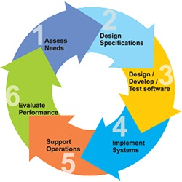

Fig 2.3 SDLC

**Stage 1: Scheduling and Requisite investigation:**

Requirement analysis is the most important and fundamental stage in SDLC. It is performed by the senior members of the team with inputs from the customer, the sales department, market surveys and domain experts in the industry. This information is then used to plan the basic project approach and to conduct product feasibility study in the economical, operational, and technical areas.

Planning for the quality assurance requirements and identification of the risks associated with the project is also done in the planning stage. The outcome of the technical feasibility study is to define the various technical approaches that can be followed to implement the project successfully with minimum risks.

## **Stage 2: Significant necessities:**

Once the requirement analysis is done the next step is to clearly define and document the product requirements and get them approved from the customer or the market analysts. This is done through. SRS. Software Requirement Specification document which consists of all the product requirements to be designed and developed during the project life cycle.

## **Stage 3: Scheming the product design:**

SRS is the reference for product architects to come out with the best architecture for the product to be developed.

**4**

Based on the requirements specified in the SRS, usually more than one design approach for the product architecture is proposed and documented in a DDS - Design Document Specification.

This DDS is reviewed by all the important stakeholders and based on various parameters as risk assessment, product robustness, design modularity, budget and time constraints, the best design approach is selected for the product.

## **Stage 4: Structure or Mounting the Product:**

## In this stage of SDLC the actual development starts and the product are built. The programming code is generated as per DDS during this stage. If the design is performed in a detailed and organized manner, code generation can be accomplished without much hassle.

Developers have to follow the coding guidelines defined by their organization and programming tools like compilers, interpreters, debuggers etc. Are used to generate the code. Different high level programming languages such as C, C++, Pascal, Java, and PHP are used for coding.

## **Stage 5: Testing the Product:**

This stage is usually a subset of all the stages as in the modern SDLC models, the testing activities are mostly involved in all the stages of SDLC. However, this stage refers to the testing only stage of the product, where product defects are reported, tracked, fixed and retested, until the product reaches the quality standards defined in the SRS.

## **Stage 6: Consumption in the Market and Safeguarding:**

Once the product is tested and ready to be deployed it is released formally in the appropriate market. The product may first be released in a limited segment and tested in the real business environment (UAT- User acceptance testing). The product may be released as it is or with suggested enhancements in the targeting market segment. After the product is released in the market, its maintenance is done for the existing customer base.

**5**

**2.4 HARDWARE AND SOFTWARE REQUIREMENTS**

|  |  |  |  |
| --- | --- | --- | --- |
| Developing Kit | | | |
|  | Processor | RAM | Disk Space |
| Eclipse | Computer with a 2.6GHz processor or higher | 2GB | Minimum 20 GB |
| Database | | | |
| MySQL 5.0 | Intel Pentium processor at 2.6GHz or faster | Minimum 512 MB Physical Memory; 1 GB Recommended | Minimum 20 GB |
| Heidi SQL 8.3 | Intel Pentium processor at 2.6GHz or faster | Minimum 512 MB Physical Memory; 1 GB Recommended | Minimum 20 GB |

Fig 2.4 hardware and software

**Software Requirements:**

* **Front end :** core java, CSS, js, servlet
* **Web application :** J2ee Frameworks, Hibernate
* **Back end :** MySQL 5.1

**2.5 INPUT AND OUTPUT**

The major inputs and outputs and major functions of the system are follows:

**Input:**

* The entities such as authority and users must register the account for login. All the user details have been stored the data in our database for the purpose of identifying the entities.
* The admin will upload the details regarding products such as product name, product price, product quantity, description of product etc.

**Output:**

* Only the authorized data users can able to access the data.
* The Saloon project uses to calculate the amount of kertain and melanin in the each and every batch of hair.

**6**

**2.6 LIMITATIONS**

* **Mushrooms' Growth Conditions:** Some mushrooms need specific, costly growth conditions, making them less reliable.
* **Overharvesting Cuttlefish:** Overharvesting cuttlefish harms marine life and disrupts biodiversity.
* **Keratin Waste Disposal:** Leftover keratin waste can be difficult and harmful to dispose of.
* **High Cost of Extraction:** Extracting melanin and keratin from some sources can be expensive.
* **Limited Availability of Sources:** Melanin and keratin sources may not always be available or sustainable.

**2.7 EXISTING SYSTEM:**

The existing system involves extracting melanin and keratin from various sources, and using them to create beauty and hair care products. Currently, melanin is often extracted from different sources like fungi (such as Auricularia a and Phellinus linteus), cuttlefish ink, and even certain bacterial strains like Pseudomonas aeruginosa. Keratin is commonly extracted from animal-based sources like chicken feathers and sheep wool using chemical or enzymatic methods. However, there’s no complete system to track and manage the extraction process in salons. The lack of a structured process for handling salon waste highlights the need for creative solutions to reduce environmental impact. The web application would address this gap by providing a platform for salons to log and track their hair waste, monitor the extraction of melanin and keratin, and connect with manufacturers for further processing. The app would optimize the extraction process using smart technologies, enabling salons to reuse their waste efficiently. Additionally, the application could also track the effectiveness of the extraction methods and generate reports to help salon owners make better decisions for waste management and product quality. It would foster collaboration between salons and manufacturers, making the entire process smoother and more eco-friendly.

**7**

**2.8 PROPOSED SYSTEM**

The proposed web application is designed to help salons manage their hair waste and turn it into useful products like sunscreens and hair care items. The system aims to reduce waste by collecting hair from salons and processing it into valuable materials like melanin and keratin. In the web application, salon owners can easily upload data about the hair they collect, including the type and amount, and track if their data is approved. The system helps them manage payments for the hair waste they contribute. Employees responsible for collecting and processing hair waste can use the app to check the quality of the hair, run tests to measure the melanin and keratin levels, and submit reports for review. Admins have full control over the entire process. They can approve salon registrations, manage product details, and track the progress of hair collection and processing. The system helps everyone stay updated with real-time information, making the whole process smooth, secure, and efficient. This web application allows salons to easily log hair waste, track payments, and ensure that the waste is processed into high-quality products, all while supporting sustainable practices. The web application also ensures that all data is securely stored, providing transparency and accountability throughout the entire process, from hair collection to product creation.

**Advantage of Proposed System:**

* **Reduces Waste & Pollution:** Hair waste that would usually go to landfills or be burned is now used for making products, which helps reduce waste and pollution.
* **Lower Greenhouse Gas Emissions:** The process can reduce the greenhouse gases typically released during regular sunscreen production, making it more eco-friendly.
* **Natural UV Protection:** Melanin extracted from hair provides natural UV protection, reducing the need for chemical UV filters that may have health risks.
* **Supports Local Communities:** Involving salons in hair waste collection helps build local partnerships and creates new economic opportunities for communities.

**8**

**CHAPTER-3**

**FEASIBILITY REPORT**

**3.1 TECHNICAL FEASIBILITY**

There are two primary biomolecules that are of interest in the extraction of melanin and keratin hair: both keratin and melanin Melanin is the pigment that gives hair its color and is used in sunscreens that block UV rays.

Because of its protective and restorative properties, keratin, a protein that gives hair strength, is useful in hair care products.

The extraction cycle includes detaching these biomolecules from hair squander under controlled conditions, including temperature changes and the utilization of ionic fluids to settle and save their honesty.

By streamlining this cycle, the undertaking intends to boost the yield and nature of the separated substances.

**3.2 OPERATIONAL FEASIBILITY**

For salon proprietors, the reconciliation of this task into everyday activities is practical. It is simple to incorporate the collection of hair waste into existing processes. Additionally, salons can enhance their brand's image as eco-conscious businesses by participating in this initiative.

The venture to change over hair squander into maintainable excellence and hair care items is both in fact and monetarily doable.

By utilizing the extraordinary properties of melanin and keratin, this drive can possibly lessen squander, fulfill developing purchaser need for eco-accommodating items, and give another income stream to the two salons and item makers.

Further improvement of the extraction cycle and choice tree calculation will be fundamental for streamlining creation and guaranteeing the outcome of this imaginative methodology.

**9**

**3.3 ECONOMIC FEASIBILITY**

The expense of the extraction cycle is a basic component. Using reused hair squander, which is frequently promptly accessible from salons, can fundamentally diminish natural substance costs. In any case, the costs connected with handling, for example, the obtaining of ionic fluids and specific hardware for temperature control, should be painstakingly made due.

There is a rising demand for eco-friendly and sustainable beauty products. Purchasers are progressively searching for items that line up with ecological qualities.

By offering magnificence and hair care items got from reused hair, the venture could take advantage of this growing business sector fragment, possibly prompting higher overall revenues.

Potential for Scaling Up Production After the extraction procedure has been optimized and shown to be effective, it is possible to increase production.

The utilization of a choice tree calculation can additionally smooth out creation, decreasing time and expenses related with experimentation techniques.

**10**

**CHAPTER – 4**

**SOFTWARE REQUIREMENT SPECIFICATION**

**4.1 INTRODUCTION**

The purpose of this document is to present a detailed description of the Web application system. It will explain the purpose and features of the system, the interfaces of the system, what the system will do, the constraints under which it must operate and how the system will react to external stimuli. This document is intended for both the stakeholders and the developers of the system and will be proposed to the Regional Historical Society for its approval.

**PURPOSE**

The purpose of this Software Requirement Specification (SRS) is to help the project. It is provided with some requirements which are used in the Transaction Mercator System. All parts; design, coding and testing will be prepared with helping of SRS. The purpose of this document is to detail the requirements placed on the Transaction Mercator System and serves as a contract between the customer and the developers as to what is to be expected of the stock exchange, and how the components of the system are working with each other with external systems.

This document will be checked by the group member’s supervisor and it will correct by members if supervisor orders.

**DEVELOPERS RESPONSIBILITIES OVERVIEW:**

The developer is responsible for:

* Developing the system, which meets the SRS and solving all the requirements of the system?
* Demonstrating the system and installing the system at client's location after the acceptance testing is successful.
* Submitting the required user manual describing the system interfaces to work on it and also the documents of the system.

**11**

* Conducting any user training that might be needed for using the system.
* Maintaining the system for a period of one year after installation.

**FUNCTIONAL REQUIREMENTS:**

* Following is a list of functionalities of the browsing enabled system.
* An Activity with a UI that allows you to browser settings. Provide a second Activity that allows users to access the share with permission from the administrator. Handle activity lifecycle appropriately. A precondition for any points in this part of the grade is code that compiles and runs.
* Your application should allow a user to browse the shares, buy and sell the shares with specific metadata. The assignment requires you to create a UI for browsing and a UI for integrating the two.
* The Net beans provide a number of useful layout components, views, and tools that you may want to use to create your location browser. As with the final project, you should design your application to only use the buttons on the Key board and mouse as input. Your application should use the Key board, Mouse and keywords.

**4.2 NON-FUNCTIONAL REQUIREMENTS:**

The system should be supported Net beans. The member should use the System browser. Each member should have a separate system. The system should ask the username and password to open the application. It doesn’t permit to unregistered user to access the System.

The system should have Role based System functions access. Approval Process has to be defined. The system should have Modular customization components so that they can be reused across the implementation.

These are the mainly following:

Secure access of confidential data. 24 X 7 availability

Better component design to get better performance at peak time

Flexible service-based architecture will be highly desirable for future extension

**12**

**4.3 PERFORMANCE REQUIREMENTS**

Performance is measured in terms of the output provided by the application. Requirement specification plays an important part in the analysis of a system. Only when the requirement specifications are properly given, it is possible to design a system, which will fit into required environment. It rests largely in the part of the users of the existing system to give the required specifications because they are the people who finally use the system. This is because the requirements have to be known during the initial stages so that the system can be designed according to those requirements. It is very difficult to change the system once it has been designed and on the other hand designing a system, which does not cater to the requirements of the user, is of no use.

The requirement specification for any system can be broadly stated as given below:

* The system should be able to interface with the existing system
* The system should be accurate
* The system should be better than the existing system

The existing system is completely dependent on the user to perform all the duties.

**13**

**CHAPTER-5**

**SYSTEM DOVELOPEMENT ENVIRONMENT**

# **5.1 INTRODUCTION TO JAVA**

**About Java**:

Initially the language was called as “oak” but it was renamed as “Java” in 1995.The primary motivation of this language was the need for a platform-independent (i.e. Architecture neutral) language that could be used to create software to be embedded in various consumer electronic devices.Java is a programmer’s language. Java is cohesive and consistent. Except for those constraints imposed by the Internet environment. Java gives the programmer, full control. Finally Java is for Internet Programming where c was to System Programming.

**Importance of Java to the Internet**

Java has had a profound effect on the Internet. This is because; Java expands the Universe of objects that can move about freely in Cyberspace. In a network, two categories of objects are transmitted between the server and the personal computer. They are passive information and Dynamic active programs. In the areas of Security and probability. But Java addresses these concerns and by doing so, have opened the door to an exciting new form of program called the Applet.

Applications and applets. An application is a program that runs on our computer under the operating system on that computer. It is more or less like one creating, using C or C++.Java’s ability to create Applets makes it important. An Applet I son application, designed to be transmitted over the Internet and executed by a Java-compatible web browser. An applet I actually a tiny Java program, dynamically downloaded across the network, just like an image. But the difference is, it is an intelligent program, not just a media file. It can be reacted to the user input and dynamically change.

**14**

**Java Architecture**

Java architecture provides a portable, robust, high performing environment for development. Java provides portability by compiling the byte codes for the Java Virtual Machine, which is then interpreted on each platform by the run-time environment. Java is a dynamic system, able to load code when needed for a machine in the same room or across the planet.

When you compile the code, the Java compiler creates machine code (called byte code) for a hypothetical machine called a Java Virtual Machine (JVM). The JVM is supposed to be executed the byte code. The JVM is created for the overcoming the issue of probability. The code is written and compiled for one machine and interpreted on all machines. This machine is called a Java Virtual Machine. Compiling and interpreting Java source code.

**Source code**

**Pc compiler**

**Macintosh compiler**

**SPARC Compiler**

**Java Byte code**

**Platform independent**

**Java interpreter**

**Java interpretermacintosh**

**)))**

**Java interpreter**

**(SPARC)**

Fig 5.1 JAVA

During run-time the Java interpreter tricks the byte code file into thinking that it is running on a Java Virtual Machine. In reality this could be an Intel Pentium windows 95 or

Sun SPARCstation running Solaris or Apple Macintosh running system and all could receive code from any computer through the internet and run the Applets.

**15**

**Simple:**

Java was designed to be easy for the Professional programmer to learn and to use effectively. If you are an experienced C++ Programmer. Learning Java will oriented features of C++. Most of the confusing concepts from C++ are either left out of Java or implemented in a cleaner, more approachable manner. In Java there are a small number of clearly defined ways to accomplish a given task.

**Object oriented**

Java was not designed to be source-code compatible with any other language. This allowed the Java team the freedom to design with a blank state. One outcome of this was a clean, usable, pragmatic approach to objects. The object model in Java is simple and easy to extend, while simple types, such as integers, are kept as high-performance non-objects.

**Robust**

The multi-platform environment of the web places extraordinary demands on a program, because the program must execute reliably in a variety of systems. The ability to create robust programs. Was given a high priority in the design of Java. Java is strictly typed language; it checks your code at compile time and runtime. Java virtually eliminates the problems of memory management and deal location, which is completely automatic. In a well-written Java program, all run-time errors can and should be managed by your program.

**16**

**5.2 SERVLETS/JSP**

A Servlet is a generic server extension. Java classes that can be loaded dynamically to expand the functionality of a server. Servlets are commonly used with web servers. Where they can take the place CGI scripts.

A Servlet is similar to proprietary server extension, except that it runs inside a Java Virtual Machine (JVM) on the server, so it is safe and portable Servlets operate solely within the domain of the server. Unlike CGI and Fast CGI, which use multiple processes to handle separate program or separate requests, separate threads within the web server process handle all servlets. This means that servlets are all efficient and scalable.

Servlets are portable; both across operating systems and also across web servers. Java Servlets offer the best possible platform for web application development.

Servlets are used as a replacement for CGI scripts on a web server; they can extend any sort of server, such as a mail server that allows servlets extend its functionality, perhaps by performing a virus scan on all attached documents or handling mail filtering tasks.

Servlets provide a Java-based solution used to address the problems currently associated with doing server-side programming including inextensible scripting solutions platform-specific API’s and incomplete interface.

Servlets are objects that conform to a specific interface that can be plugged into a Java-based server. Servlets are to the server-side what applets are to the server-side what applets are to the client-side-object byte codes that can be dynamically loaded off the net. They differ from applets in than they are faceless objects(without graphics or a GUI component). They serve as platform independent, dynamically loadable, pluggable helper byte code objects on the server side that can be used to dynamically extend server-side functionality.

**17**

**Attractiveness of servlets:**

They are many features of servlets that make them easy and attractive to use these include:

* Easily configure using the GUI-based Admin tool]
* Can Be Loaded and Invoked from a local disk or remotely across the network.
* Can be linked together or chained, so that on servlet can call another servlet or several servlets in sequence.
* Can be called dynamically from within HTML, pages using server-side include-tags.
* Are secure-even when downloading across the network, the servlet security model and servlet and box protect your system from unfriendly behavior.

**Advantages of the Servlet API**

One of the great advantages of the servlet API is protocol independent. It assumes nothing about:

* The protocol being used to transmit on the net
* How it is loaded
* The server environment it will be running in

These quantities are important, because it allows the Servlet API to be embedded in many different kinds of servers.

There are other advantages to the servlet API as well these include:

* It’s extensible-you can inherit all your functionality from the base classes made available to you
* It’s small, simple, and easy to use.

**Features of Servlets:**

* Servlets are persistent. Servlet is loaded only by the web server and can maintain services between requests.

**18**

* Servlets are fast. Since servlets only need to be l\loaded once, they offer much better performance over their CGI counterparts.
* Servlets are platform independent.
* Servlets are extensible Java is a robust, object-oriented programming language, which easily can be extended to suit your needs.
* Servlets are secure
* Servlets are used with a variety of clients.

Every servlet must implement the javax.servlet interface. Most servlets implement it by extending one of two classes.javax.servlet.GenericServlet or javax.servlet.http.HttpServlet.

A protocol-independent servlet should subclass Generic-Servlet. While an Http servlet should subclass HttpServlet, which is itself a subclass of Generic-servlet with added HTTP-specific functionality.

Unlike a java program, a servlet does not have a main () method, Instead the server in the process of handling requests invoke certain methods of a servlet. Each time the server dispatches a request to a servlet, it invokes the servlets Service () method.

A generic servlet should override its service () method to handle requests as appropriate for the servlet. The service() accepts two parameters a request object and a response object. The request object tells the servlet about the request, while the response object is used to return a response

In Contrast. an Http servlet usually does not override the service () method. Instead, it overrides do Get () to handle GET requests and do Post () to handle Post requests. An Http servlet can override either or both of these modules the service() method of HttpServlet handles the setup and dispatching to all the do XXX() methods. Which is why it usually should not be overridden

**19**

The remainders in the javax. servlet and Java. servlet. http. The package is largely supported class’s. TheServletRequest and ServletResponse classes in Java. servlet is provided access to generic server requests and responses while HttpServletRequest and HttpServletResponse classes in javax.servlet provide access to generic server requests and responses while HttpServletRequest and HttpServletResponse in javax.servlet.http provide access a HTTP requests and responses. The javax.servlet.http provide contains an HttpSession class that provides built-in session tracking functionality and Cookie class that allows quick setup and processing Http Cookies.

**Loading Servlets:**

Servlets can be loaded from their places. From a directory that is in the CLASSPATH. The CLASSPATH of the Java Webserver includes service root/classes/, which is where the system classes reside

From the <SERVICE_ROOT/servlets/directory. This is not in the server’s class path. A class loader is used to create servlet form this directory. New servlets can be added-existing servlets can be recompiled and the server will notice these changes. From a remote location. For this a code base like <http://nine.eng/classes/foo/> is required in addition to the servlet’s class name. Refer to the admin GUI docs on servlet section to see how to set this up.

Loading Remote Servlets

Remote servlets can be loaded from:

* Configuring the admin Tool to setup automatic loading of remote servlets.
* Selection up server side include tags in .html files

**Invoking Servlets**

A servlet invoker is a servlet that invokes the “server” method of a named servlet. If the servlet is not loaded into the server, then the invoker first loads the servlet (either form local disk or from the network) and the then invokes the “service” method.Also like applets, local servlets in the server can be identified by just the class name.In other words, if a servlet name is not absolute. It is treated as local.

**20**

A Client cans Invoke Servlets in the Following Ways:

* The client can ask for a document that is served by the servlet.
* The client(browser) can invoke the servlet directly using a URL, once it has been mapped using the SERVLET ALIASES Section of the admin GUI
* The servlet can be invoked through server side include tags.
* The servlet can be invoked by placing it in the servlet/directory
* The servlet can be invoked by using it in a filter chain

**The Servlet Life Cycle:-**

The Servlet life cycle is one of the most exciting features of Servlets.This life cycle is a powerful hybrid of the life cycles used in CGI programming and lower-level NSAPI and ISAPI programming.

The Servlet life cycle allows servlet engines to address both the performance and resource problems of CGI and the security consents of low level server API programming.

The servlet life cycle is highly flexible Servers have significant leeway in how they choose to support servlets. The only hard and fast rule is that a servlet engine must conform to the following life cycle contract:

* Create and initialize the servlets
* Handle zero or more service for clients
* Destroy the servlet and then garbage collects it.

It’s perfectly legal for a servlet t be loaded, created an initialized in its own JVM, only to be destroyed a garbage collected without handling any client request or after handling just one request

The most common and most sensible life cycle implementations for HTTP servlets are: Single Java virtual machine and astatine persistence.

**21**

**Init and Destroy:-**

Just like Applets servlets can define init () and destroy () methods, A servlets init (ServiceConfig) method is called by the server immediately after the server constructs the servlet instance. Depending on the server and its configuration, this can be at any of these times

* When the server states
* When the servlet is first requested, just before the service() method is invoked
* At the request of the server administrator

The init () method is typically used to perform servlet initialization creates or loading objects that are used by the servlet in the handling of its request. In order to provide a new Servlet any information about itself and its environment, a server has to call a servletsinit () method and pass an object that implement the ServletConfig interface.

This ServletConfig object supplies a servlet with information about its initialization parameters. These parameters are given to the servlets and are not associated with any single request.They can specify initial values, such as where a counter should begin counting, or default values, perhaps a template to use when not specified by the request,

The server calls a servlet destroy () method when the servlet is about to be unloaded. In the destroy () method, a Servlet should free any resources it has acquired that will not be garbage collected. The destroy () method also gives a servlet a chance to write out its unsaved. Cached information or any persistent information that should be read during the next call to init ().

**USER AUTHORIZATION:**

One way to perform session tracking is to leverage the information that comes with User authorization. When a web server restricts access to some of its resources to only those clients that log in using a recognized username and password. After the client logs in, the username is available to a servlet through getRemoteUser ().

**22**

When use the username to track the session. Once a user has logged in, the browser remembers her user name and resends the name and password as the user views new pages on the site. A servlet can identify the user through her username and they’re by Track her session.

The biggest advantage of using user authorization to perform session tracking is that it’s easy to implement. Simply tell the protect a set of pages, and use getRemoteUser() to identify each client. Another advantage is that the technique works even when the user accesses your site form or exits her browser before coming back.

The biggest disadvantage of user authorization is that it requires each user to register for an account and then log in each time the starts visiting your site. Most users will tolerate registering and logging in as a necessary evil when they are accessing sensitive information, but it’s all overkill for simple session tracking.Another problem with user authorization is that a user cannot simultaneously maintain more than one session at the same site.

**Hidden Form Fields:**

One way to support anonymous session tracking is to use hidden from the fields. As the name implies, these are fields added to an HTML, from that are not displayed in the client’s browser, they are sent back to the server when the form that contains them is submitted.

In a sense, hidden form fields define constant variables for a form. For a servlet receiving a submitted form, there is no difference between a hidden field and a visible filed.

As more information is associated with a client’s session. It can become burdensome to pass it all using hidden form fields. In these situations, it’s possible to pass on just a unique session ID that identifies as a particular client session.

That session ID can be associated with complete information about its session that is stored on the server.

**23**

The advantage of hidden form fields is their ubiquity and support for anonymity. Hidden fields are supported in all the popular browsers, they demand on special server requirements, and they can be used with clients that haven’t registered or logged in

The major disadvantage with this technique, however, is that works only for a sequence of dynamically generated forms, the technique breaks down immediately with static documents, emailed documents bookmarked documents and browser shutdowns.

**URL Rewriting:**

URL rewriting is another way to support anonymous session tracking, With URL rewriting every local URL the user might click on is dynamically modified. Or rewritten, to include extra, information. The extra information can be in the form of extra path information, added parameters, or some custom, server-specific.URL change. Due to the limited space available in rewriting a URL, the extra information is usually limited to a unique session. Each rewriting technique has its own advantage and disadvantage

Using extra path information works on all servers, and it works as a target for forms that use both the Get and Post methods. It does not work well if the servlet has to use the extra path information as true path information

The advantages and disadvantages of URL. Rewriting closely match those of hidden form fields, The major difference is that URL rewriting works for all dynamically created documents,

such as the Help servlet, not just forms. With the right server support, custom URL rewriting can even work for static documents.

**Persistent Cookies:**

A fourth technique to perform session tracking involves persistent cookies. A cookie is a bit of information. Sent by a web server to a browser that can later be read back form that browser. When a browser receives a cookie, it saves the cookie and there after sending the cookie back to the server each time it accesses a page on that server, subject to certain rules.

**24**

Because a cookie’s value can uniquely identify a client, cookies are often used for session tracking.

Persistent cookies offer an elegant, efficient, easy way to implement session tracking. Cookies provide as automatic an introduction for each request, as we could hope for. For each request, a cookie can automatically provide a client’s session ID or perhaps a list of clients' performance.

The ability to customize cookies gives them extra power and versatility. The biggest problem with cookies is that browsers don’t always accept cookies sometimes this is because the browser doesn’t support cookies. More often it’s because the browser doesn’t support cookies. More often it’s because the user has specifically configured the browser to refuse cookies.

**The power of servlets:**

The power of servlets is nothing but the advantages of servlets over other approaches, which include portability, power, efficiency, endurance, safety, elegance, integration, extensibility and flexibility.

**Portability:**

As servlets are written in Java and conform to a well defined and widely accepted API. They are highly portable across operating systems and across server implementation

We can develop a servlet on a Windows NT machine running the Java web server and later deploy it effortlessly on a high-end UNIX server running Apache. With servlets we can really “write once, serve everywhere”

Servlet portability is not the stumbling block it so often is with applets, for two reasons

First, Servlet portability is not mandatory, i.e. servlets have to work only on server machines that we are using for development and deployment

Second, servlets avoid the most error-prone and inconstancy implemented portions of the Java languages.

**25**

**Power:**

Servlets can harness the full power of the core Java. API’s: such as Networking and Url access, multithreading, image manipulation, data compression, database connectivity, internationalization, remote method invocation (RMI) CORBA connectivity, and object serialization, among others.

**Efficiency and Endurance:**

Servlet invocation is highly efficient, Once a servlet is loaded it generally remains in the server’s memory as a single object instance, Thereafter the server invokes the servlet to handle a request using a simple, light weighted method invocation. Unlike the CGI, there’s no process to spawn or interpreter to invoke, so the servlet can begin handling the request almost immediately, Multiple, concurrent requests is handled the request almost immediately. Multiple, concurrent requests are handled by separate threads, so servlets are highly scalable.

Servlets in general are enduring objects. Because a servlet stays in the server’s memory as a single object instance. It automatically maintains its state and can hold onto external resources, such as database connections.

**Safety:**

Servlets support safe programming practices on a number of levels.As they are written in Java, servlets inherit stronger type safety of the Java language. In addition the servlet API is implemented to be type safe. Java’s automatic garbage collection and lack of pointers mean that servlets are generally safe from memory management problems like dangling pointers invalid pointer references and memory leaks.

Servlets can handle errors safely, due to Java exception – handling mechanism. If a servlet divides by zero or performs some illegal operations, it throws an exception that can be safely caught and handled by the server.

A server can further protect itself from servlets through the use of Java security manager. A server can execute its servlets under the watch of a strict security manager.

**26**

**Elegance:**

The elegance of the servlet code is striking.Servlet code is clean, object oriented modular and amazingly simple one reason for this simplicity is the served API itself. This includes methods and classes to handle many of the routine chores of servlet development. Even advanced to operations like cookie handling and session tracking are abstracted into convenient classes.

**Integration:**

Servlets are tightly integrated with the server. This integration allows a servlet to cooperate with the server in two ways. For e.g.: a servlet can use the server to translate file paths, perform logging, check authorization, perform MIME type mapping and in some cases even add users to the server’s user database.

**Extensibility and Flexibility:**

The servlet API is designed to be easily extensible. As it stands today the API includes classes that are optimized for HTTP servlets. But later it can be extended and optimized for another type of servlets. It is also possible that its support for HTTP servlets could be further enhanced.

Servlets are also quite flexible; Sun also introduced Java server pages. Which offer a way to write snippets of servlet code directly within a static HTML page using syntax similar to Microsoft’s Active server pages (ASP).

**5.3 JDBC**

**What is JDBC?**

Any relational database. One can write a single program using the JDBC API,and the JDBC is a Java Api for executing SQL,Statements(As a point of interest JDBC are trademarks names and is not an acronym; nevertheless, Jdbc is often thought of as standing for Java Database Connectivity.

**27**

It consists of a set of classes and interfaces written in the Java Programming language.JDBC provides a standard API for tool/database developers and makes it possible to write database applications using a pure Java APIUsing JDBC, it is easy to send SQL statements to virtually program will be able to send SQL Statements to the appropriate database. The Combination of Java and JDBC lets a programmer writes it once and run it anywhere.

**What Does JDBC Do?**

**Simply put, JDBC makes it possible to do three things**

* Establish a connection with a database
* Send SQL statements
* Process the results
* JDBC Driver Types
* The JDBC drivers that we are aware of this time fit into one of four categories
* JDBC-ODBC Bridge plus ODBC driver
* Native-API party-Java driver
* JDBC-Net pure Java driver
* Native-protocol pure Java driver

An individual database system is accessed via a specific JDBC driver that implements the java.sql.Driver interface. Drivers exist for nearly all-popular RDBMS systems, through few are available for free. Sun bundles a free JDBC-ODBC bridge driver with the JDK to allow access to a standard ODBC, data sources, such as a Microsoft Access database, Sun advises against using the bridge driver for anything other than development and very limited development.

JDBC drivers are available for most database platforms, from a number of vendors and in a number of different flavors. There are four driver categories

**Type 01-JDBC-ODBC Bridge Driver**

Type 01 drivers use a bridge technology to connect a Java client to an ODBC database service. Sun’s JDBC-ODBC bridge is the most common type 01 driver. These drivers implemented using native code.

**28**

**Type 02-Native-API party-Java Driver**

Type 02 drivers wrap a thin layer of Java around a database-specific native code libraries for Oracle databases, the native code libraries might be based on the OCI(Oracle call Interface) libraries, which were originally designed for c/c++ programmers, Because type-02 drivers are implemented using native code. In some cases, they have better performance than their all-Java counterparts. They add an element of risk, however, because a defect in a driver’s native code section can crash the entire server

**Type 03-Net-Protocol All-Java Driver**

Type 03 drivers communicate via a generic network protocol to a piece of custom middleware. The middleware component might use any type of driver to provide the actual database access. These drivers are all Java, which makes them useful for applet deployment and safe for servlet deployment

**Type-04-native-protocol All-Java Driver**

Type o4 drivers are the most direct of the lot. Written entirely in Java, Type 04 drivers understand database-specific networking. Protocols and can access the database directly without any additional software

**JDBC-ODBC Bridge**

If possible use a Pure Java JDBC driver instead of the Bridge and an ODBC driver. This completely eliminates the client configuration required by ODBC.It also eliminates the potential that the Java VM could be corrupted by an error in the native code brought in by the Bridge (that is, the Bridge native library, the ODBC driver manager library, library, the ODBC driver library, and the database client library).

**WHAT IS The JDBC-ODBE Bridge?**

The JDBC-ODBC Bridge is a Jdbc driver, which implements JDBC operations by translating them into ODBC operations. To ODBC it appears as a normal application program. The Bridge is implemented as the sun.jdbc.odbc Java package and contains a native library used to access ODBC.

**29**

**5.4 HTML, JAVASCRIPT**

Hypertext Markup Language(HTML), the languages of the World Wide Web (WWW), allows users to produce web pages that included text, graphics and pointer to other web pages (Hyperlinks).

HTML is not a programming language, but it is an application of ISO Standard 8879, SGML (Standard Generalized Markup Language), but Specialized to hypertext and adapted to the Web. The idea behind Hypertext one point to another point. We can navigate through the information based on out interest and preference. A markup language is simply a series of items enclosed within the elements should be displayed. Hyperlinks are underlined or emphasized works that load to other documents or some portions of the same document.

HTML can be used to display any type of document on the host computer, which can be geographically at a different location. It is a versatile language and can be used on any platform or desktop. HTML provides tags (special codes) to make the document look attractive.

HTML provides are not case-sensitive. Using graphics, fonts, different sizes, color, etc., can enhance the presentation of the document. Anything that is not a tag is part of the document itself.

**30**

**Basic Html Tags**:

<!-- --> Specific Comments.

<A>………</A> Creates Hypertext links.

<B>………</B> Creates hypertext links.

<Big>……..</Big> Formats text in large-font

<Body>……. </Body> contains all tags and text in the Html-document

<Center>……</Center> Creates Text

<DD>………..</DD> Definition of a term.

<TABLE>…… </TABLE> creates a table

<Td>………..</Td> indicates table data in a table.

<Tr>………..</Tr> designates a table row

<Th>………. </Th> creates a heading in a table.

##### **ADVANTAGE**

* + A HTML document is small and hence easy to send over the net. It is small because it does not include formatted information.
  + HTML is platform independent
  + HTML tags are not case-sensitive.

**31**

**5.5 JAVA SCRIPT**

**The Java Script Language**

JavaScript is a compact, object-based scripting language for developing client and server internet applications. Netscape Navigator 2.0 interprets JavaScript statements embedded directly in an HTML page. And Livewire enables you to create server-based applications similar to common gateway interface (CGI) programs. In a client application for Navigator, JavaScript statements embedded in an HTML Page can recognize and respond to user events such as mouse clicks form input, and page navigation.

For example, you can write a JavaScript function to verify that users enter valid information into a form requesting a telephone number or zip code. Without any network transmission, an Html page with embedded Java Script can interpret the entered text and alert the user with a message dialog if the input is invalid or you can use JavaScript to perform an action (such as play an audio file, execute an applet, or communicate with a plug-in) in response to the user opening or exiting a page.

**32**

**CHAPTER-6**

**SYSTEM DESIGN**

**6.1 INTRODUCTION**

Lately, supportability and advancement have become essential in changing ventures in all cases, and the excellence and salon industry is no exemption. The Keratin The board Task is a noteworthy drive that lines up with these standards by tending to two squeezing difficulties: enhancing the efficacy of hair care products and reducing salon waste. The goal of this project is to make high-quality, engineered beauty and hair care products out of waste hair, specifically human hair. This will help preserve the environment and advance technology in beauty products. Melanin and keratin, two essential biomolecules that play a crucial role in both color and structural integrity, are found in human hair. Melanin, which gives tone to the hair, is additionally important for its UV-hindering properties. Keratin, a protein significant for hair strength, adds to the plan of various hair care items. The Keratin Management Project hopes to develop products that not only enhance beauty but also offer enhanced UV protection and overall efficacy by harnessing these substances. The project's use of decision tree algorithms to improve product development is novel. Based on data analysis, decision trees are used to classify and predict the best outcomes, assisting in the selection of the best conditions for processing and utilizing these hair-derived substances. This strategy not just works on the productivity of the extraction cycle yet additionally helps with the advancement of modified answers for different hair types and needs. Looking forward, the Keratin The board Task imagines further headways in refining the extraction strategies, increasing creation, and investigating extra applications for melanin and keratin.

**MODULES:**

1. Client
2. Saloon Owner
3. Collection Management
4. Process Analysis
5. Admin

**33**

**MODULE 1: CLIENT**

This module allows clients to register and log in securely using their credentials. After logging in, clients can explore the product catalog uploaded by the admin, with detailed information such as descriptions, prices, and features available for each product. They can add products to the cart, update quantities, or remove items as needed, ensuring flexibility in managing their selections. The checkout process ensures clients fill in necessary fields such as payment and delivery details before completing the order. Once the order is successfully placed, a unique order ID is generated for confirmation. The client can log out to secure their account and conclude the session. This module provides a comprehensive and user-friendly flow, covering all essential e-commerce operations.

**MODULE 2: SALON OWNER**

This module enables salon owners to manage their operations efficiently. The process starts with the salon owner registering their personal and shop details on the sign-up page, followed by receiving an admin-approved password to log in. After logging in, the salon owner can upload relevant data such as the amount of hair collected, collection month, type of hair, and services provided. Once the data is uploaded, the owner can view its status—whether it is approved or rejected by the admin. If approved, the salon owner must register their bank details to enable payment processing. They can then track the payment status to see whether the admin has processed the payment. After completing these steps, the salon owner can log out securely. This module streamlines registration, data management, and payment tracking, ensuring a smooth and transparent experience.

**MODULE 3: COLLECTION MANAGEMENT**

This module is designed to streamline the tasks of the collection management employee. The process begins with the employee registering their personal information and employee details on the sign-up page. Once the registration is completed, the employee must wait for admin approval to receive a password.

**34**

With the admin-approved password, the employee can log in securely. After successfully logging in, the collection management employee gains access to salon data that has been approved by the admin. The employee reviews the approved reports and uploads data to initiate operations. The operations focus on analyzing the amount of melanin and keratin present in the specific batch of hair collected. Upon completing the analysis, the employee generates a detailed report and submits it to the admin for further review. After performing all required operations and submitting the reports, the employee securely logs out of the module. This module ensures a structured workflow for registration, data analysis, and reporting, facilitating smooth and efficient operations for the collection management employee.

**MODULE 4: PROCESS ANALYSIS**

This module is designed for the Process Analysis Employee to handle critical operations. The workflow begins with the employee registering their personal information and employee details on the sign-up page. After successful registration, the employee must await admin approval to receive their login credentials. Using the admin-approved password, the employee can log in securely to the module. Once logged in, the Process Analysis Employee can view the collection management data that has been approved by the admin. After reviewing the data, the employee uploads the melanin and keratin data to perform specific tests. These tests involve conducting temperature-based experiments on the extracted melanin and keratin using ionic liquids. During these tests, the employee analyzes the various results and observations derived from the experiments. A detailed report is then prepared and submitted to the admin for review and further action. After completing all assigned tasks and submitting the necessary reports, the Process Analysis Employee securely logs out of the module. This module provides a structured and streamlined process for data review, experimental testing, and reporting, ensuring efficient and precise operations.

**35**

**MODULE 5: ADMIN**

This module enables the admin to manage and oversee operations across all modules. After logging in, the admin processes the log status of users registering in different modules (salon owners, collection management, and process analysis) and approves their access. The admin uploads product details, visible in the client module for purchases. In the salon module, the admin reviews reports from salon owners, accepts or rejects them, allocates payments for approved reports, and processes transactions. In the collection module, the admin examines reports uploaded by collection management employees and decides on approval. Similarly, in the process analysis module, the admin reviews the results of tests conducted on melanin and keratin. This module ensures efficient control of all operations and records.

**6.2 SYSTEM ARCHITECTURE:**

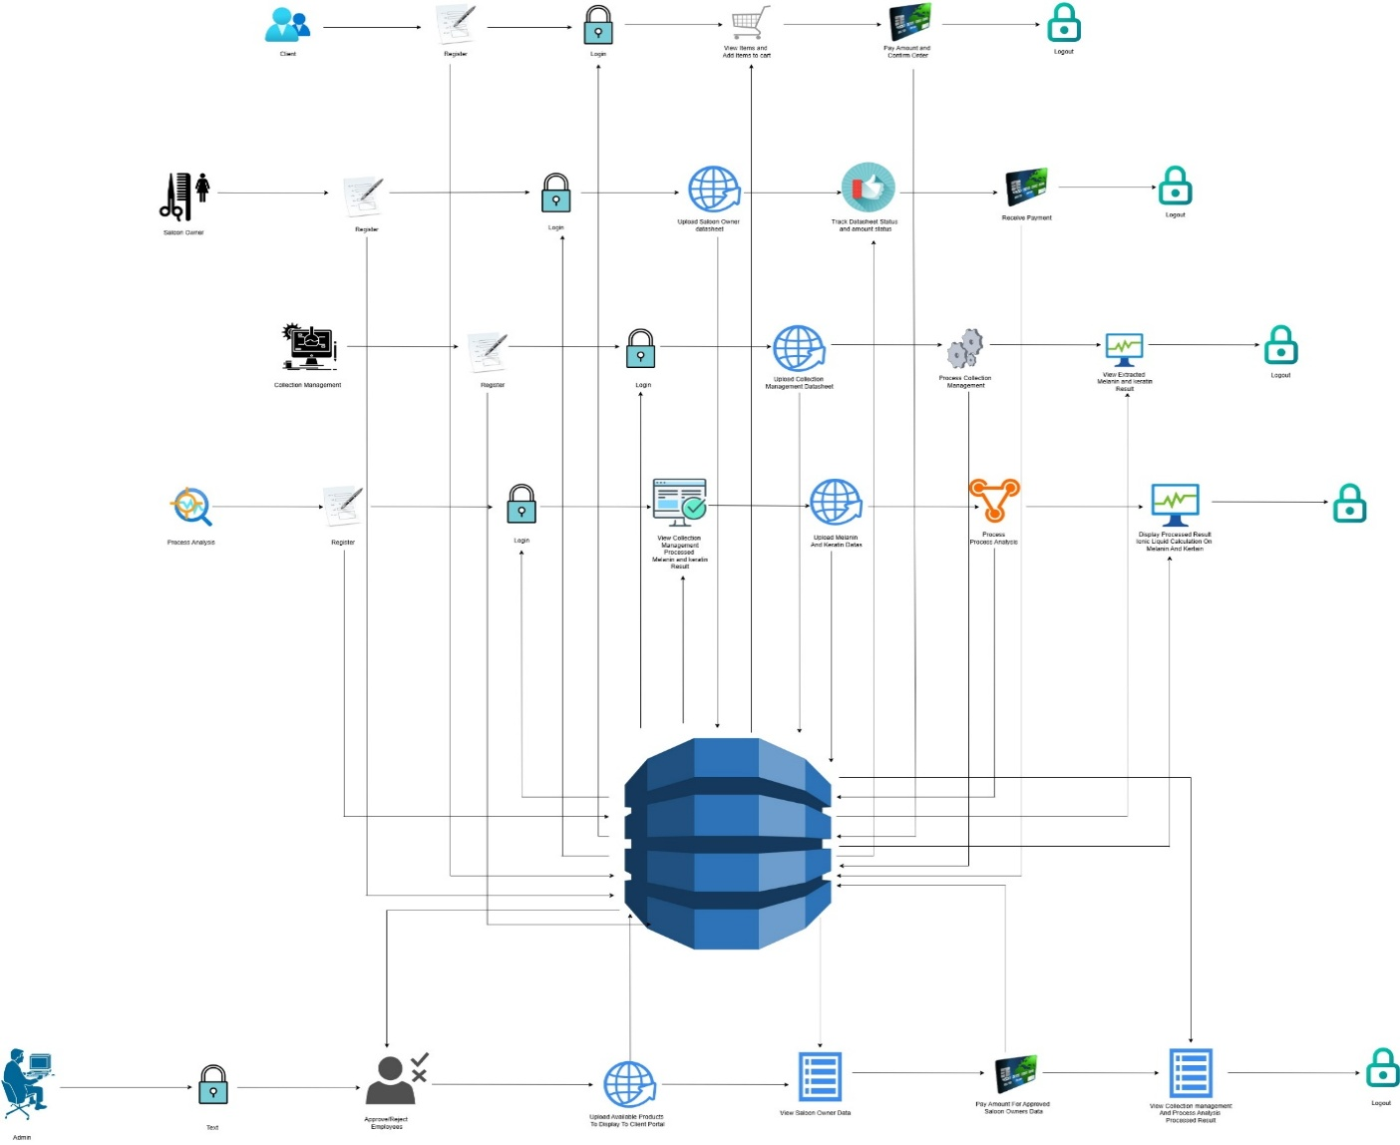

Fig 6.2 system architecture

**36**

**6.3 E – R DIAGRAMS**

The relation upon the system is structured through a conceptual ER-Diagram, which not only specifics the existing entities, but also the standard relations through which the system exists and the cardinalities that are necessary for the system state to continue.

The Entity Relationship Diagram (ERD) depicts the relationship between the data objects. The ERD is the notation that is used to conduct, the date modeling activity the attributes of each data object noted, is the ERD can be described resign a data object description.

The set of primary components that are identified by the ERD are

* + 1. Data object
    2. Relationships
    3. Attributes
    4. Various types of indicators.

The primary purpose of the ERD is to represent data objects and their relationships.

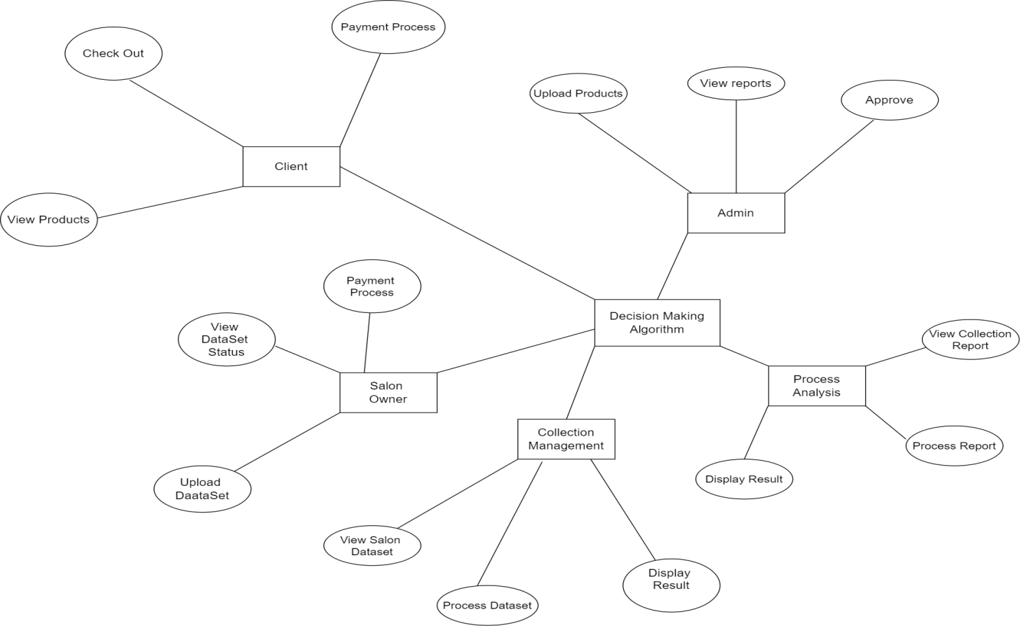

Fig 6.3 E-R diagram

**37**

**6.4 FLOW DIAGRAMS**

A data flow diagram is a graphical tool used to describe and analyze the movement of data through a system. These are the central tool and the basis from which the other components are developed. The transformation of data from input to output through processing, may be described logically and independently of physical components associated with the system. These are known as the logical data flow diagrams. The physical data flow diagrams show the actual implements and movement of data between people, departments and workstations. A full description of a system actually consists of a set of data flow diagrams. Using two familiar notations Yourdon, Gane and Sarson notation develops the data flow diagrams. Each component in a DFD is labeled with a descriptive name. The process is further identified with a number that will be used for identification purpose. The development of DFD’S is done on several levels. Each process in lower level diagrams can be broken down into a more detailed DFD in the next level. The lop-level diagram is often called context diagram. It consist a single process bit, which plays a vital role in studying the current system. The process in the context level diagram is exploded into another process at the first level DFD.

The idea behind the explosion of a process into more process is that understanding at one level of detail is exploded into greater detail at the next level. This is done until further explosion is necessary and an adequate amount of detail is described for analysts to understand the process.

Larry Constantine first developed the DFD as a way of expressing system requirements in a graphical form, this lead to the modular design.

A DFD is also known as a “bubble Chart” has the purpose of clarifying system requirements and identifying major transformations that will become programmed in system design. So it is the starting point of the design to the lowest level of detail. A DFD consists of a series of bubbles joined by data flows in the system.

**38**

**6.5 DFD SYMBOLS**

In the DFD, there are four symbols

1. A square defines a source (originating) or destination of system data
2. An arrow identifies data flow. It is the pipeline through which the information flows
3. A circle or a bubble represents a process that transforms the incoming data flow into outgoing data flows.
4. An open rectangle is a data store, data at rest or a temporary repository of data

A process that transforms the data flow

Source or Destination of data

Data flow

Data Store

**CONSTRUCTING A DFD:**

Several rules of thumb are used in drawing DFD’S:

1. Process should be named and numbered for an easy reference. Each name should be representative of the process.
2. The direction of flow is from top to bottom and from left to right. Data traditionally flow from source to the destination although they may flow back to the source. One way to indicate this is to draw the long flow line back to a source. An alternative way is to repeat the source symbol as a destination. Since it is used more than once in the DFD it is marked with a short diagonal.

**39**

1. When a process is exploded into lower level details, they are numbered.
2. The names of data stores and destinations are written in capital letters. Process and dataflow names have the first letter of each work capitalized

A DFD typically shows the minimum contents of data store. Each data store should contain all the data elements that flow in and out.

Questionnaires should contain all the data elements that flow in and out. Missing interfaces redundancies and like is then accounted for often through interviews.

**SAILENT FEATURES OF DFD’S**

1. The DFD shows the flow of data, not of control loops and decision are controlled considerations do not appear on a DFD.
2. The DFD does not indicate the time factor involved in any process, whether the dataflow take place daily, weekly, monthly or yearly.
3. The sequence of events is not brought out on the DFD.

**TYPES OF DATA FLOW DIAGRAMS**

1. Current Physical
2. Current Logical
3. New Logical
4. New Physical

**CURRENT PHYSICAL**

In Current Physical DFD process label includes the name of the people or their positions or the names of computer systems that might provide some of the overall system-processing label includes an identification of the technology used to process the data. Similarly, data flows and data stores are often labelled with the names of the actual physical media on which data are stored such as file folders, computer files, business forms or computer tapes.

**40**

**CURRENT LOGICAL:**

The physical aspects in the system are removed as much as possible so that the current system is reduced to its essence to the data and the processes that transform them regardless of actual physical form.

**NEW LOGICAL:**

This is exactly like a current logical model if the user were completely happy with the user were completely happy with the functionality of the current system, but had problems with how it was implemented typically through the new logical model will differ from the current logical model while having additional functions, absolute function removal and inefficient flows recognized.

**NEW PHYSICAL:**

The new physical represents only the physical implementation of the new system.

**RULES GOVERNING THE DFD’S**

**PROCESS**

1. No process can have only outputs.
2. No process can have only inputs. If an object has only inputs than it must be a sink.
3. A process has a verb phrase label.

**DATA STORE**

1. Data cannot move directly from one data store to another data store, a process must move data.
2. Data cannot move directly from an outside source to a data store, a process, which receives, must move data from the source and place the data into the data store
3. A data store has a noun phrase label.

**41**

**SOURCE OR SINK**

The origin and /or destination of data

1. Data cannot move direly from a source to sink it must be moved from a process
2. A source and /or sink have a noun phrase land

**DATA FLOW**

1. A Data Flow has only one direction of flow between symbols. It may flow in both directions between a process and a data store to show a read before an update. The latter is usually indicated, however by two separate arrows since these happen at different type.
2. A join in DFD means that exactly the same data comes from any of two or more different processes data store or sink to a common location.
3. A data flow cannot go directly back to the same process it leads. There must be at least one other process that handles the data flow produce some other data flow returns the original data in the beginning process.
4. A Data flow to a data store means update (delete or change).
5. A data Flow from a data store means retrieve or use.

A data flow has a noun phrase label more than one data flow noun phrase can appear on a single arrow as long as all of the flows on the same arrow move together as one package.

**42**

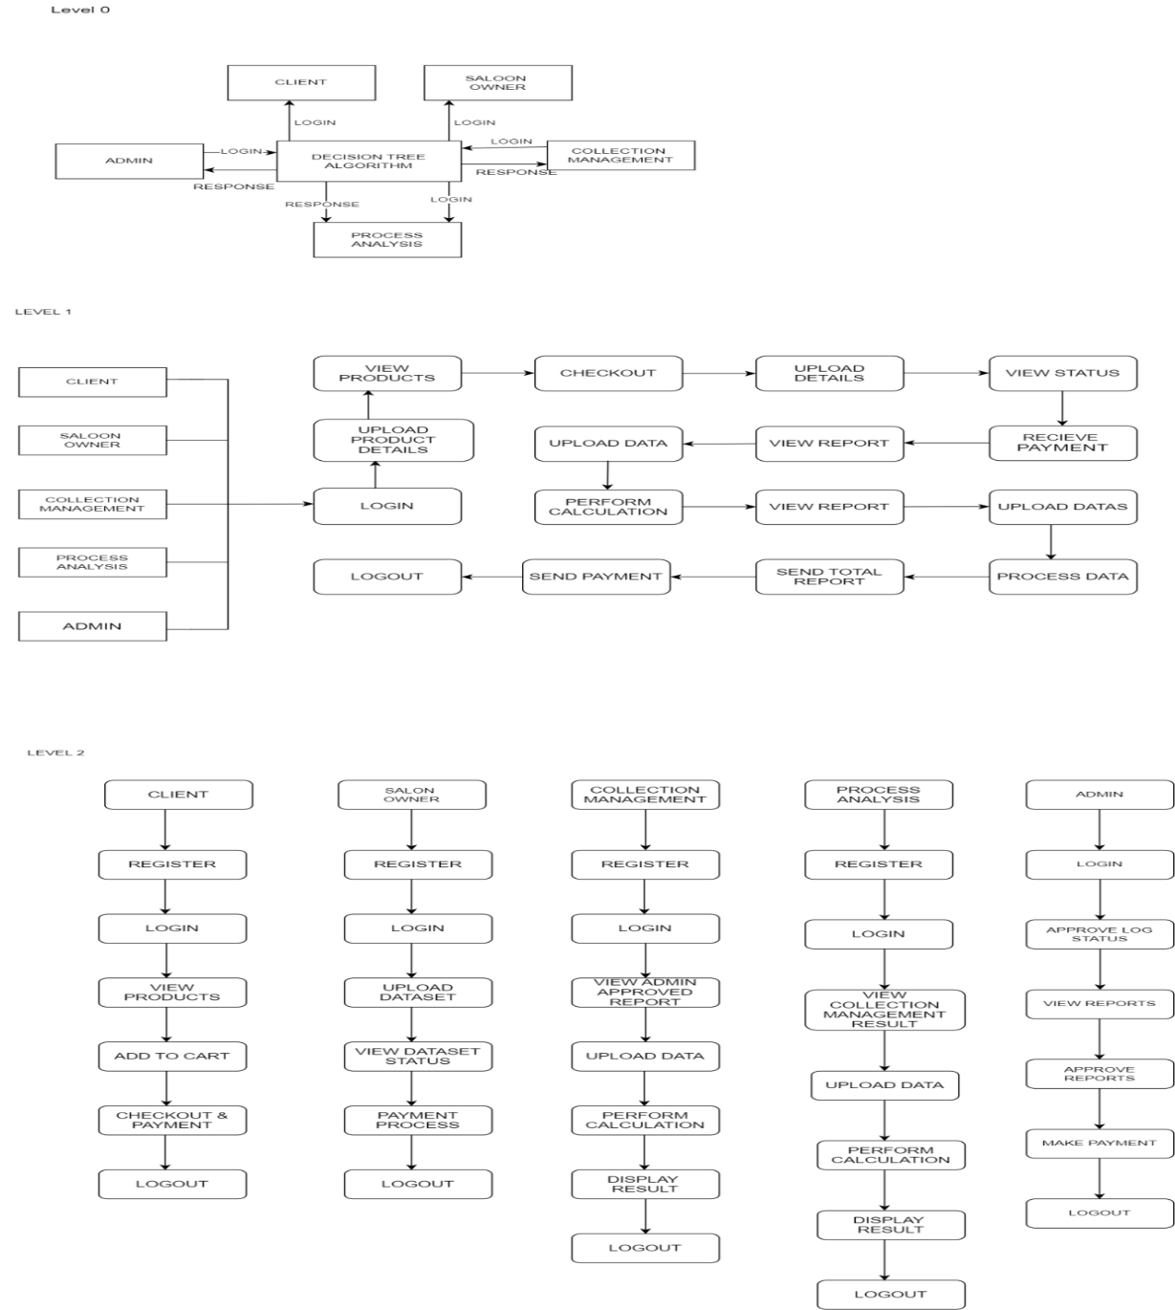**DATA FLOW DIAGRAM**

Fig 6.5 data flow diagram **43**

**6.6 USE CASE DIAGRAM**

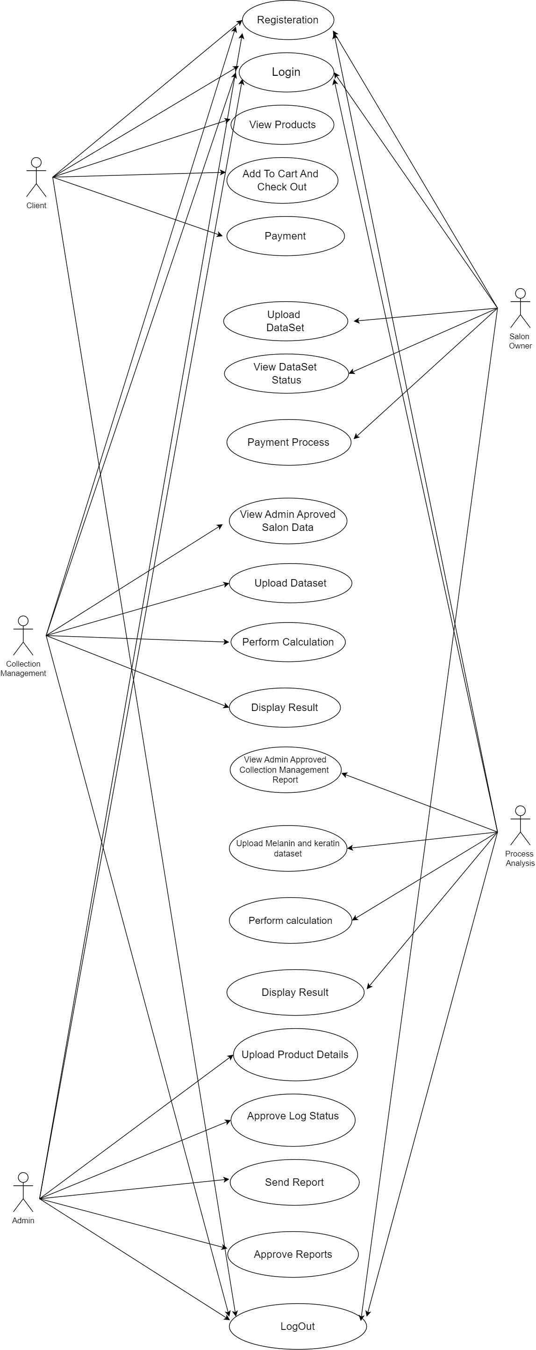

Fig 6.6 use case diagram

44

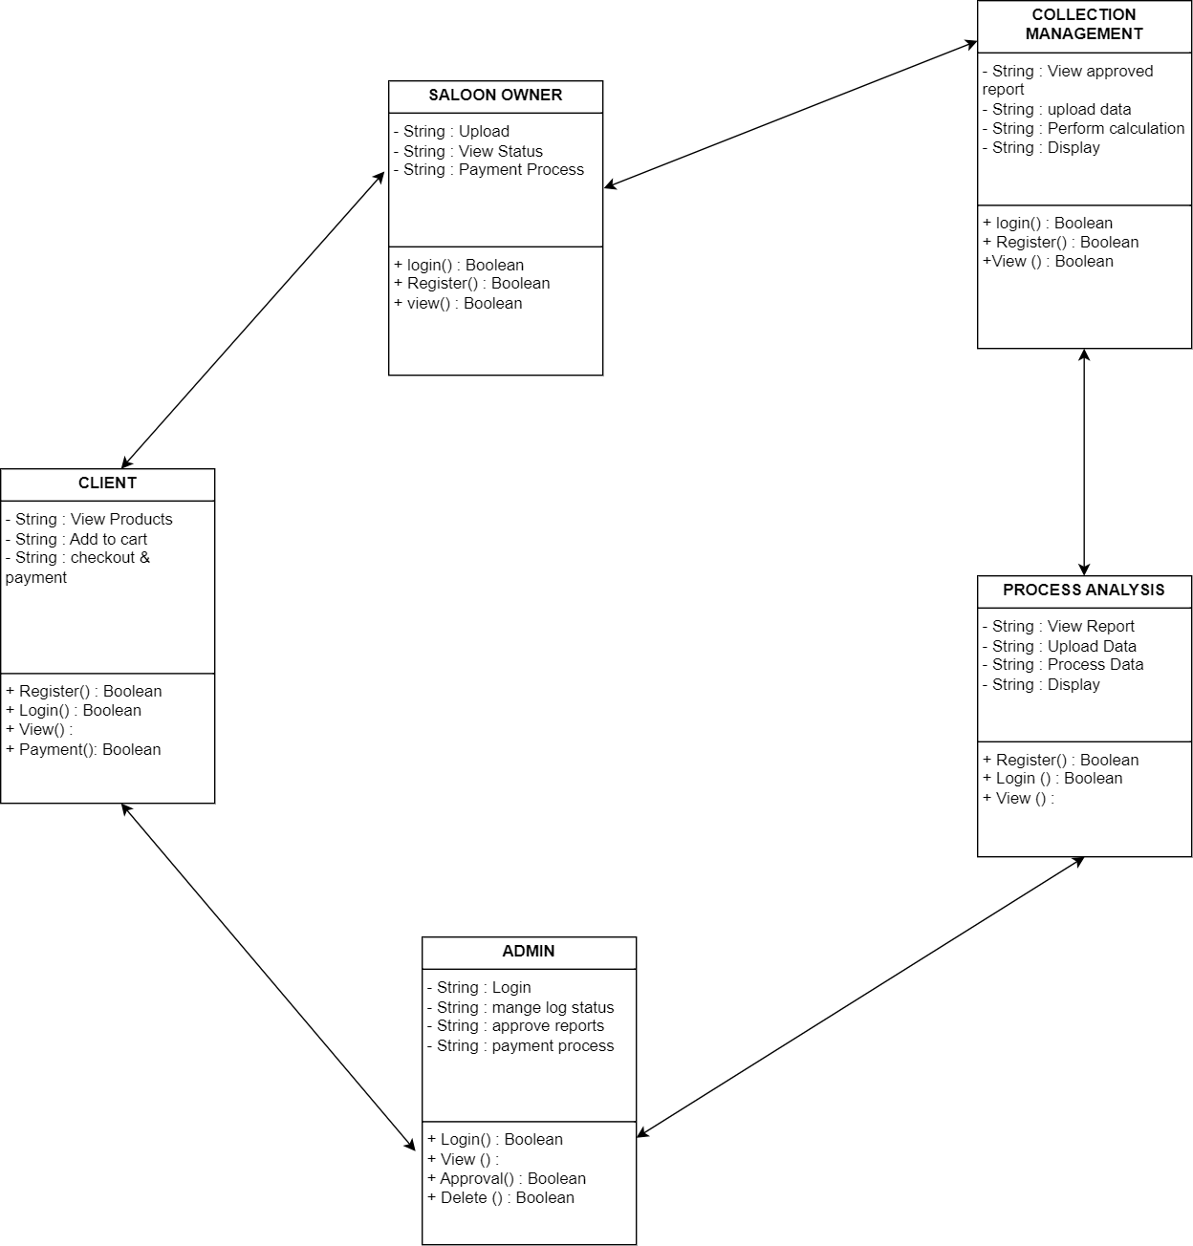**6.7 CLASS DIAGRAM**

Fig 6.7 class diagram

45

**CHAPTER - 7**

**SYSTEM TESTING AND IMPLEMENTATION**

**7.1. INTRODUCTION**

Software testing is a critical element of software quality assurance and represents the ultimate review of specification, design and coding. In fact, testing is the one step in the software engineering process that could be viewed as destructive rather than constructive.

**7.2. SOFTWARE TESTING**

The software engineering process can be viewed as a spiral. Initially system engineering defines the role of software and leads to software requirement analysis where the information domain, functions, behavior, performance, constraints and validation criteria for software are established. Moving inward along the spiral, we come to design and finally to coding. To develop computer software we spiral in along streamlines that decrease the level of abstraction on each turn.

A strategy for software testing may also be viewed in the context of the spiral. Unit testing begins at the vertex of the spiral and concentrates on each unit of the software as implemented in source code. Testing progress is done by moving outward along the spiral to integration testing, where the focus is on the design and the construction of the software architecture. Talking another turn on outward on the spiral we encounter validation testing where requirements established as part of software requirements analysis are validated against the software that has been constructed. Finally, we arrive at system testing, where the software and other system elements are tested as a whole.

**46**

WHITEBOX TESTING

BLACKBOX TESTING

MODULE TESING

SUB-SYSTEM TESTING

UNIT TESTING

Fig 7.1 software testing

**7.3. TESTING PROCEDURES**

Unit testing focuses verification effort on the smallest unit of software design, the module. The unit testing we have is white box oriented and some modules the steps are conducted in parallel.

**1. WHITE BOX TESTING**

This type of testing ensures that

* All independent paths have been exercised at least once
* All logical decisions have been exercised on their true and false sides
* All loops are executed at their boundaries and within their operational bounds
* All internal data structures have been exercised to assure their validity.

To follow the concept of white box testing we have tested each form. We have created independently to verify that Data flow is correct, All conditions are exercised to check their validity, All loops are executed on their boundaries.

**47**

**2. BLACK BOX TESTING**

The established technique of flow graph with Cyclamate complexity was used to derive test cases for all the functions. The main steps in deriving test cases were:

Use the design of the code and draw correspondent flow graphs.

Determine the Cyclamate complexity of the resultant flow graph, using formula:

V (G) =E-N+2 or

V (G) =P+1 or

V (G) =Number of Regions

Where V (G) is Cyclomatic complexity,

E is the number of edges,

N is the number of flow graph nodes,

P is the number of predicate nodes.

Determine the basis of set of linearly independent paths.

**3. MODULE TESTING**

In this part of the testing each of the conditions were tested to both true and false aspects. And all the resulting paths were tested. So that each path that may be generated on particular condition is traced to uncover any possible errors.

**4. SUB SYSTEM TESTING**

This type of testing selects the path of the program, according to the location of the definition and use of variables. This kind of testing was used only when some local variable were declared. The definition-use chain method was used in this type of testing. These were particularly useful in nested statements.

**48**

**5. UNIT TESTING**

In this type of testing all the loops are tested to all the limits possible. The following exercise was adopted for all loops:

* All the loops were tested at their limits, just above them and just below them.
* All the loops were skipped at least once.
* For nested loop test the innermost loop first and then work outwards.
* For concatenated loops the values of dependent loops were set with the help of a connected loop.

**49**

**CHAPTER – 8**

**SYSTEM SECURITY**

# **8.1 INTRODUCTION**

**S**ecurity system can be divided into four related issues: The protection of computer based resources that includes hardware, software, data, procedures and people against unauthorized use or natural

Disaster is known as System Security.

* Security
* Integrity
* Privacy
* Confidentiality

**SYSTEM SECURITY** refers to the technical innovations and procedures applied to the hardware and operation systems to protect against deliberate or accidental damage from a defined threat.

**DATA SECURITY** is the protection of data from loss, disclosure, modification and destruction.

**SYSTEM INTEGRITY** refers to the power functioning of hardware and programs, appropriate physical security and safety against external threats such as eavesdropping and wiretapping.

**PRIVACY** defines the rights of the user or organizations to determine what information they are willing to share with or accept from others and how the organization can be protected against unwelcome, unfair or excessive dissemination of information about it.

**CONFIDENTIALITY** is a special status given to sensitive information in a database to minimize the possible invasion of privacy. It is an attribute of information that characterizes its need for protection.

**50**

**8.2 SECURITY IN SOFTWARE**

System security refers to various validations on data in the form of checks and controls to avoid the system from failing. It is always important to ensure that only valid data is entered and only valid operations are performed on the system. The system employs two types of checks and controls:

**CLIENT SIDE VALIDATION**

Various client side validations are used to ensure on the client side that only valid data is entered. Client side validation saves server time and load to handle invalid data. Some checks are imposed:

* JavaScript in used to ensure those required fields are filled with suitable data only. Maximum lengths of the fields of the forms are appropriately defined.
* Forms cannot be submitted without filling up the mandatory data so that manual mistakes of submitting empty fields that are mandatory can be sorted out at the client side to save the server time and load.
* Tab-indexes are set according to the need and taking into account the ease of use while working with the system.

**SERVER SIDE VALIDATION**

Some checks cannot be applied on the client side. Server side checks are necessary to save the system from failing and intimating the user that some invalid operation has been performed or the performed operation is restricted. Some of the server side checks imposed is:

* A server side constraint has been imposed to check for the validity of primary key and foreign key. A primary key value cannot be duplicated. Any attempt to duplicate the primary value results in a message intimating the user about those values through the forms using foreign key can be updated only of the existing foreign key values.
* The user is intimated through appropriate messages about the successful operations or exceptions occurring at server side.

**51**

* Various Access Control Mechanisms have been built so that one user may not agitate upon another. Access permissions to various types of users are controlled according to the organizational structure.
* Only permitted users can log on to the system and can have access according to their category. User- name, passwords and permissions are controlled the server side.
* Using server-side validation, constraints on several restricted operations are imposed.

**52**

**CHAPTER – 9**

**CONCLUSION**

By redirecting hair squander from landfills and using it to remove melanin, the exploration plans to essentially diminish natural contamination and advance feasible waste administration rehearses inside the salon business. The improvement of eco-accommodating sunscreens integrating hair-determined melanin offers a characteristic option in contrast to conventional sun security items. This development lines up with expanding shopper interest for economical and normal skincare arrangements. Key regions for development incorporate improving the extraction interaction to improve proficiency and limit ecological effect, refining sunscreen definitions to guarantee viability and client fulfillment, and increasing creation for more extensive business accessibility. Past sunscreen, investigating extra purposes for hair-determined melanin in UV-defensive items, for example, dress and window movies could open up new business sectors and applications, further improving the monetary suitability and natural advantages of the innovation. Through cutting edge extraction processes and thorough quality control gauges, the undertaking looks to deliver excellent melanin reasonable for use in eco-accommodating sunscreens. Fruitful execution depends on conquering specialized difficulties, guaranteeing administrative consistence, and laying out adaptable creation processes. In addition to providing a sustainable source of sun protection products, achieving these objectives could revolutionize salon waste management practices. This creative methodology not just offers a maintainable answer for overseeing salon squander yet in addition adds to the improvement of more secure and all the more naturally dependable skincare items.

**53**

**FUTURE ENHANCEMENTS**

* Advanced Extraction Techniques: Improve melanin and keratin extraction methods for higher yield and better quality.
* Scalability: Expand the system to support more salons and manufacturers across different regions.
* Mobile Application: Develop a mobile app for easy access, real-time updates, and better user engagement.
* AI Integration: Use deep learning models to predict product quality based on hair type and composition.
* Blockchain Integration: Implement blockchain for secure, transparent tracking of hair waste and transactions.
* Eco-Impact Dashboard: Add analytics to measure sustainability impact like waste reduction and carbon savings.
* Multi-Language Support: Offer the application in various languages for global accessibility.
* Reward System: Introduce incentives or subscriptions to encourage eco-friendly practices among salons.
* Research Collaboration: Partner with institutions to explore new uses for hair-based materials in other industries.
* Automated Sorting: Use IoT and computer vision to automatically sort and classify hair waste for processing.

**54**

**APPENDIX 1.1**

Home Page: index.html

<!DOCTYPE html>

<html lang=*"en"*>

<head>

<title>Salon clients and owners keratin management processing</title>

<meta name=*"viewport"* content=*"width=device-width, initial-scale=1"*>

<meta http-equiv=*"Content-Type"* content=*"text/html; charset=utf-8"* />

<meta name=*"keywords"* content=*"My Design Responsive web template, Bootstrap Web Templates, Flat Web Templates, Android Compatible web template,*

*Smartphone Compatible web template, free webdesigns for Nokia, Samsung, LG, SonyEricsson, Motorola web design"* />

<script type=*"application/x-javascript"*> addEventListener("load", **function**() { setTimeout(hideURLbar, 0); }, **false**);

**function** hideURLbar(){ window.scrollTo(0,1); } </script>

<link rel=*"stylesheet"* href=*"others/css/swipebox.css"* type=*"text/css"* media=*"all"*

<link href=*"others/css/aos.css"* rel=*"stylesheet"* type=*"text/css"* media=*"all"* /><!-- //animation effects-css-->

<link rel=*"stylesheet"* href=*"others/css/index.css"*>

<link href=*"others/css/bootstrap.css"* rel=*"stylesheet"* type=*"text/css"* media=*"all"* />

<link href=*"others/css/style.css"* rel=*"stylesheet"* type=*"text/css"* media=*"all"* />

<link href=*"others/css/font-awesome.css"* rel=*"stylesheet"*>

<link href=*"//fonts.googleapis.com/css?family=Open+Sans:300,300i,400,400i,600,600i,700,700i,800,800i&amp;subset=cyrillic,cyrillic-ext,greek,greek-ext,latin-ext,vietnamese"* rel=*"stylesheet"*>

<link href=*"//fonts.googleapis.com/css?family=Cairo:200,300,400,600,700,900&amp;subset=arabic,latin-ext"* rel=*"stylesheet"*>

</head>

**55**

<body id=*"page-top"* data-spy=*"scroll"* data-target=*".navbar-fixed-top"*>

<!-- banner -->

<div class=*"banner"* id=*"home"*>

<div class=*"agileinfo-dot"*>

<div class=*"container"*>

<!-- header -->

<div class=*"header-w3layouts"*>

<!-- Navigation -->

<nav class=*"navbar navbar-default navbar-fixed-top"*>

<div class=*"navbar-header page-scroll"*>

<button type=*"button"* class=*"navbar-toggle"* data-toggle=*"collapse"* data-target=*".navbar-ex1-collapse"*>

<span class=*"sr-only"*>From Hair Waste To High-Tech: Turning Salon Scraps Into Sunscreen</span>

<span class=*"icon-bar"*></span>

<span class=*"icon-bar"*></span>

<span class=*"icon-bar"*></span>

</button>

<h1><a class=*"navbar-brand"* href=*"index.html"*>Hair Reusable</a></h1>

</div>

<div class=*"collapse navbar-collapse navbar-ex1-collapse"*>

<ul class=*"nav navbar-nav navbar-right cl-effect-15"*>

<li class=*"hidden"*><a class=*"page-scroll"* href=*"#page-top"*></a> </li>

<li><a class=*"page-scroll scroll"* href=*"clientlogin.html"*>Client</a></li>

<li><a href=*"saloonowner.jsp"*>Saloon Owner</a><li>

<li><a href=*"collectionmanagement.jsp"*>Collection Management</a></li>

<li><a href=*"ProcessAnalysis.jsp"*>Process Analysis</a></li> <li><a href=*"admin.html"*>Admin</a></li>

**56**

</ul>

</div>

</nav>

</div>

<div class=*"w3_banner_info"*>

<div class=*"w3_banner_info_grid"*>

<h2 data-aos=*"fade-right"*>"Happiness is a good hair day."</h2>

<p>From Hair Waste To High-Tech: Turning Salon Scraps Into Sunscreen.</p>

</div>

</div>

<div class=*"thim-click-to-bottom"*>

<a href=*"#about"* class=*"scroll"*>

<i class=*"fa fa-arrows-v"* aria-hidden=*"true"*></i>

</a>

</div>

</div>

</div>

</div>

<div class=*"about"* id=*"about"*>

<h3 data-aos=*"zoom-in"*>About Us</h3>

<div class=*"col-md-6 about-left"*>

<p>Hair is a rich source of keratin, a protein, and melanin, the pigment responsible for hair color.

Researchers extract these compounds through a process involving heat, hydrochloric acid, and chemical dialysis.

**57**

Melanin, in particular, has natural UV-blocking properties, making it a potential sunscreen ingredient.

This approach offers a double benefit:

Reduces waste: Hair scraps from salons would be diverted from landfills and put to good use.

Creates eco-friendly sunscreens: Hair-derived melanin could potentially lead to more sustainable sun protection products.

It's still under development, but this research holds promise for the future of waste management and sun protection.

</p>

</div>

<div data-aos=*"flip-right"* class=*"col-md-6 about-right"*>

<img src=*"others/images/about.jpg"* alt=*""* />

</div>

<div class=*"clearfix"*></div>

</div>

<script type=*"text/javascript"* src=*"others/js/jquery-2.1.4.min.js"*></script>

<script src=*"others/js/bootstrap.js"*></script>

<script src=*"others/js/cbpFWTabs.js"*></script>

<script> (**function**() {

[].slice.call( document.querySelectorAll( '.tabs' ) ).forEach( **function**( el ) {

**new** CBPFWTabs( el );

});

})();

</script>

<script src=*"others/js/jquery.swipebox.min.js"*></script>

**58**

<script type=*"text/javascript"*>

jQuery(**function**($) {

$(".swipebox").swipebox();

});

</script>

<script src=*"others/js/scrolling-nav.js"*></script><script src=*"others/js/index.js"*></script>

<script src=*"others/js/aos.js"*></script><!-- //animation effects-js-->

<script src=*"others/js/aos1.js"*></script><!-- //animation effects-js-->

<script src=*"others/js/SmoothScroll.min.js"*></script>

<script type=*"text/javascript"* src=*"others/js/move-top.js"*></script>

<script type=*"text/javascript"* src=*"others/js/easing.js"*></script>

<!-- here stars scrolling script -->

<script type=*"text/javascript"*>

$(document).ready(**function**() {

/*

var defaults = {

containerID: 'toTop', // fading element id

containerHoverID: 'toTopHover', // fading element hover id

scrollSpeed: 1200,

easingType: 'linear'

};

*/

$().UItoTop({ easingType: 'easeOutQuart' });

});

</script>

<script type=*"text/javascript"*>

**59**

jQuery(document).ready(**function**($) {

$(".scroll").click(**function**(event){

event.preventDefault();

$('html,body').animate({scrollTop:$(**this**.hash).offset().top},1000);

});

});

</script>

</body>

</html>

**60**

**APPENDIX 1.2**

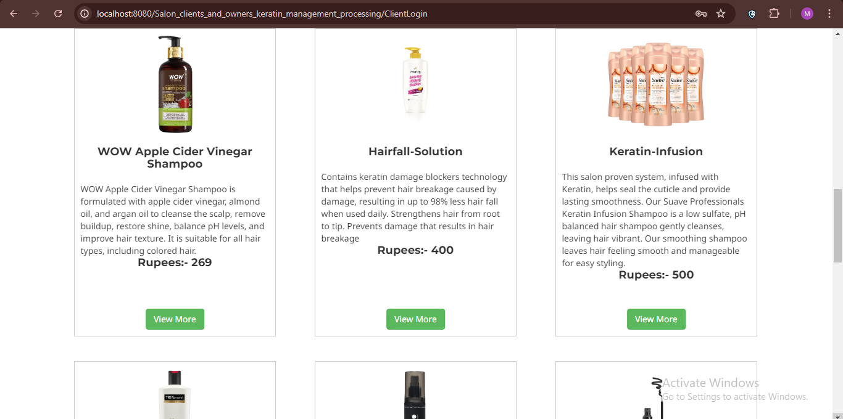

**Fig 1.1 product view**

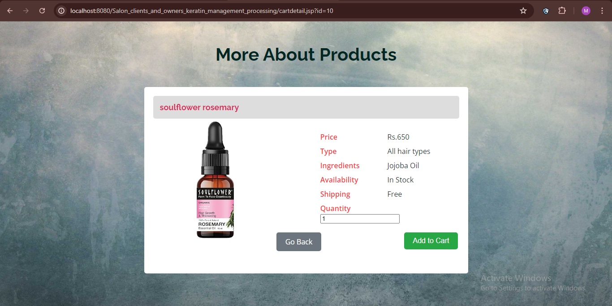

**Fig 1.2 add cart**

**61**

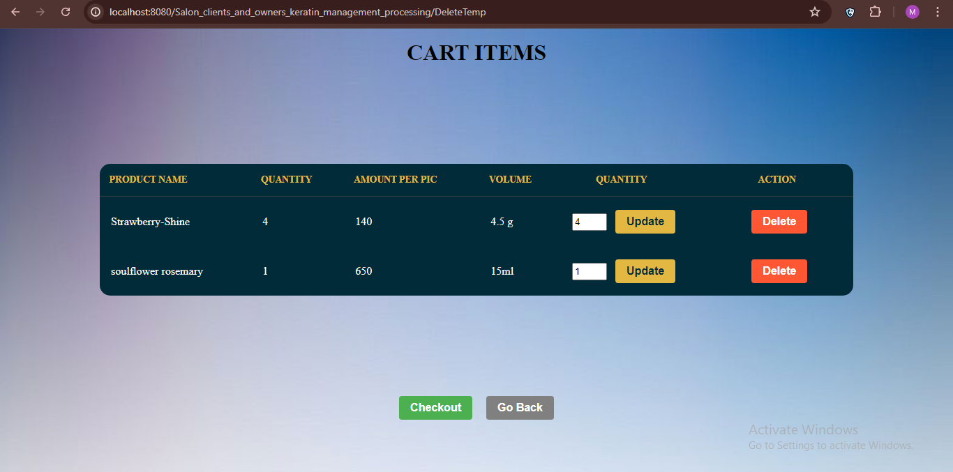

**Fig 1.3 checkout**

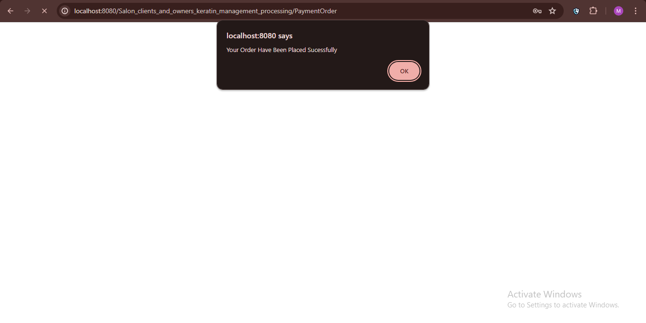

**Fig 1.4 order placed**

**62**

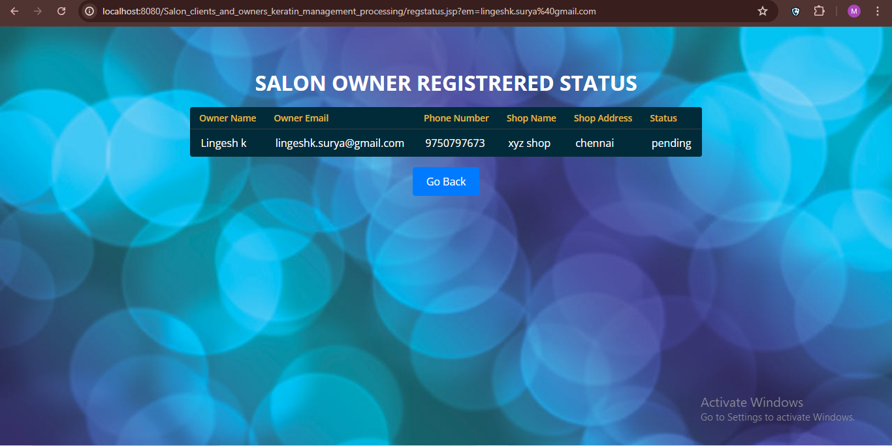

**Fig 1.5 salon owner register**

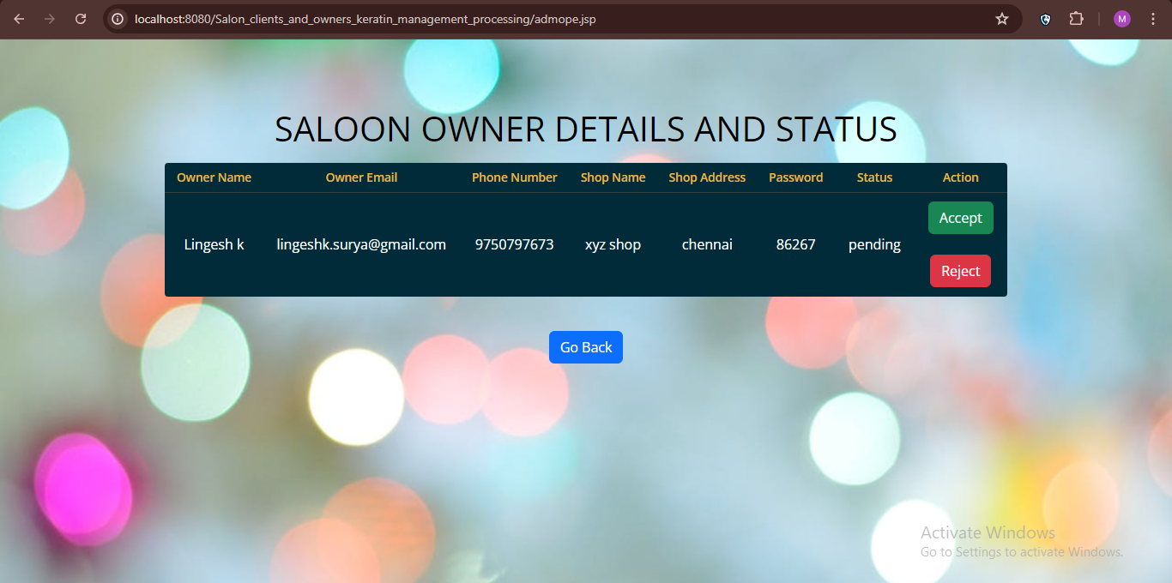

**Fig 1.6 waiting for acceptance**

**63**

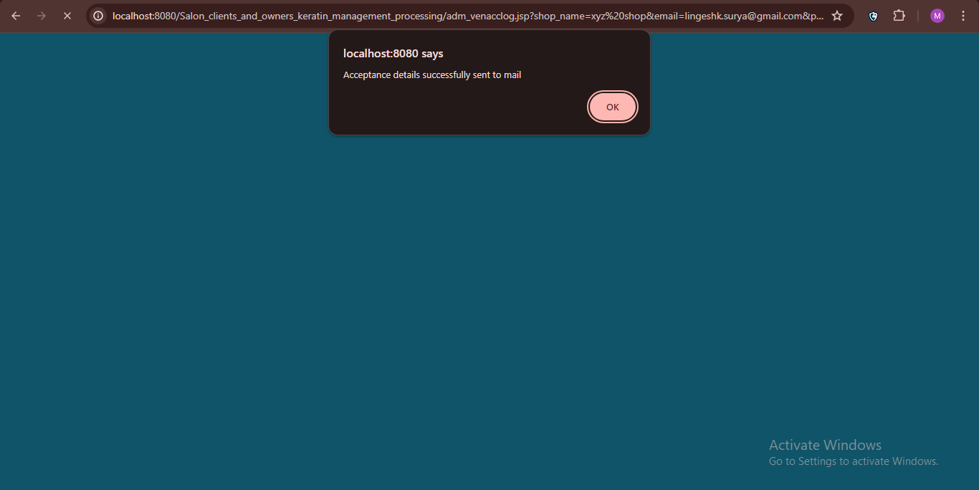

**Fig 1.7 acceptance**

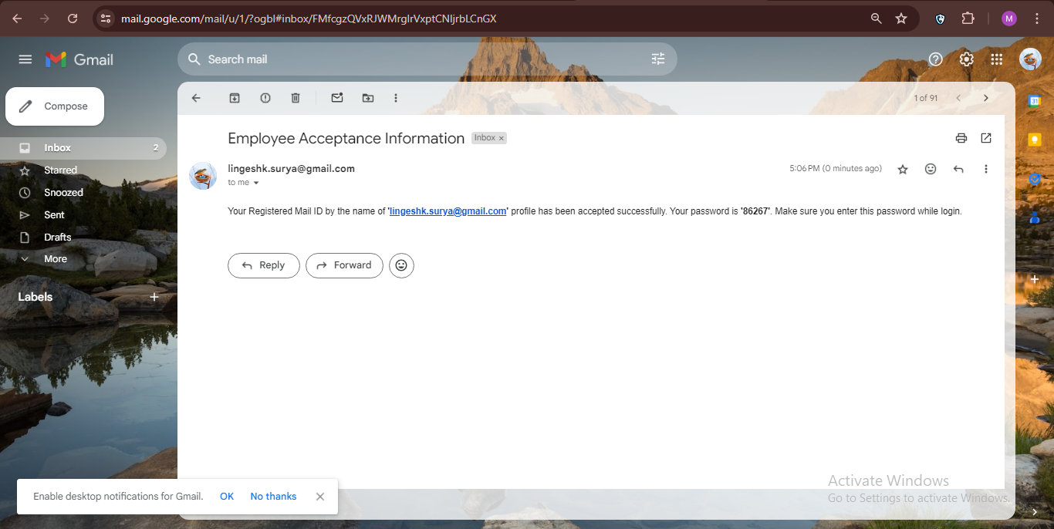

**Fig 1.8 generate password**

**64**

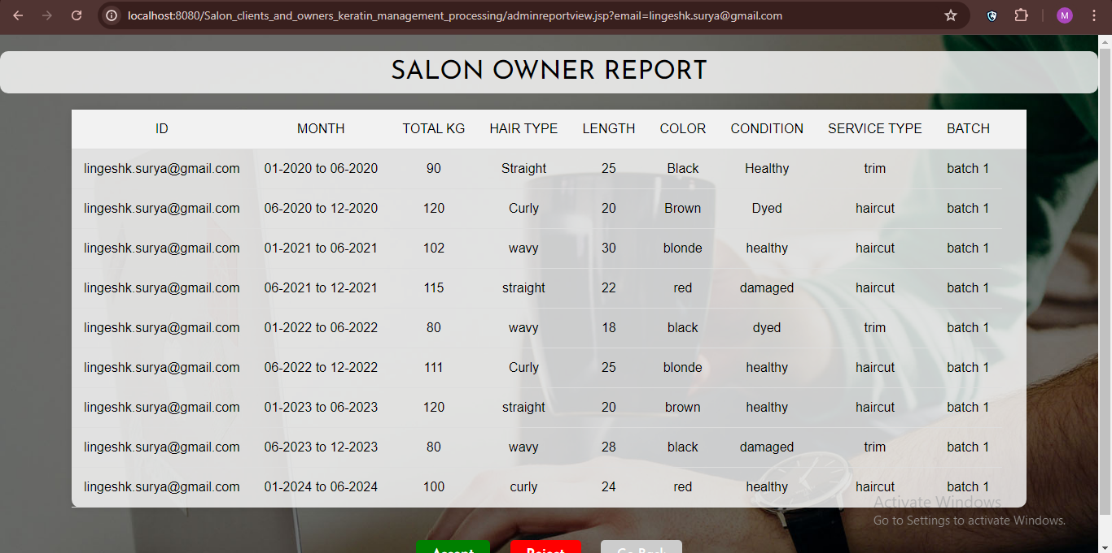

**Fig 1.9 saloon report**

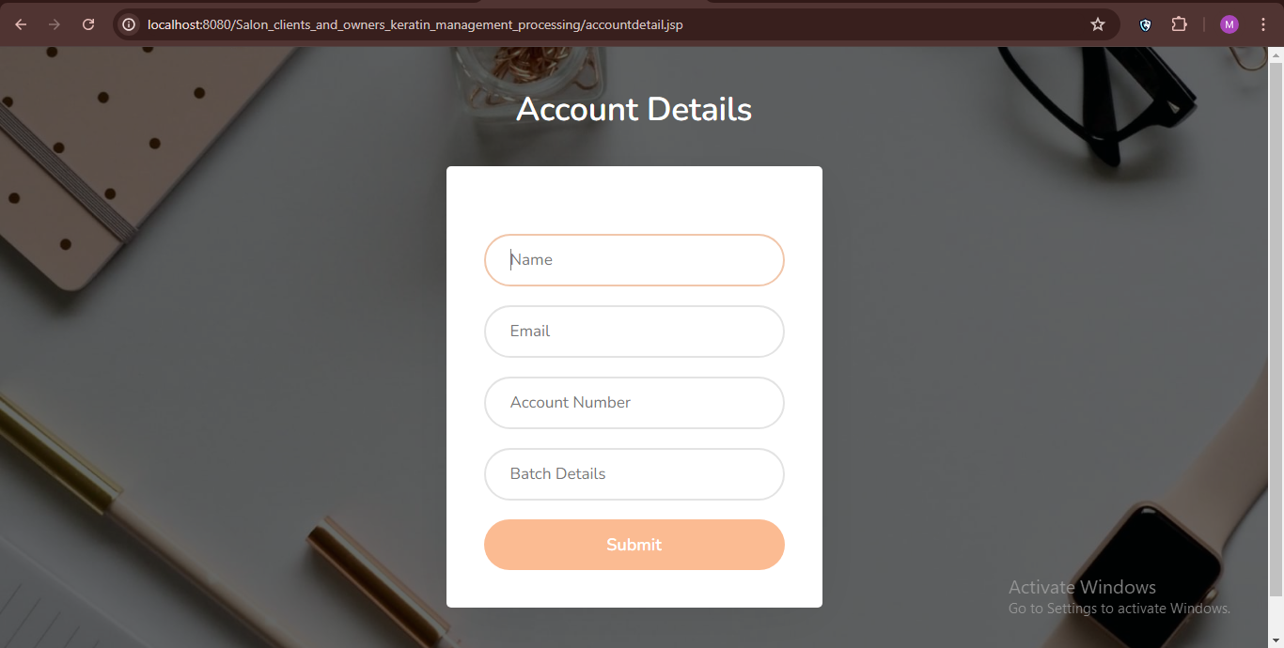

**Fig 1.10 account details**

**65**

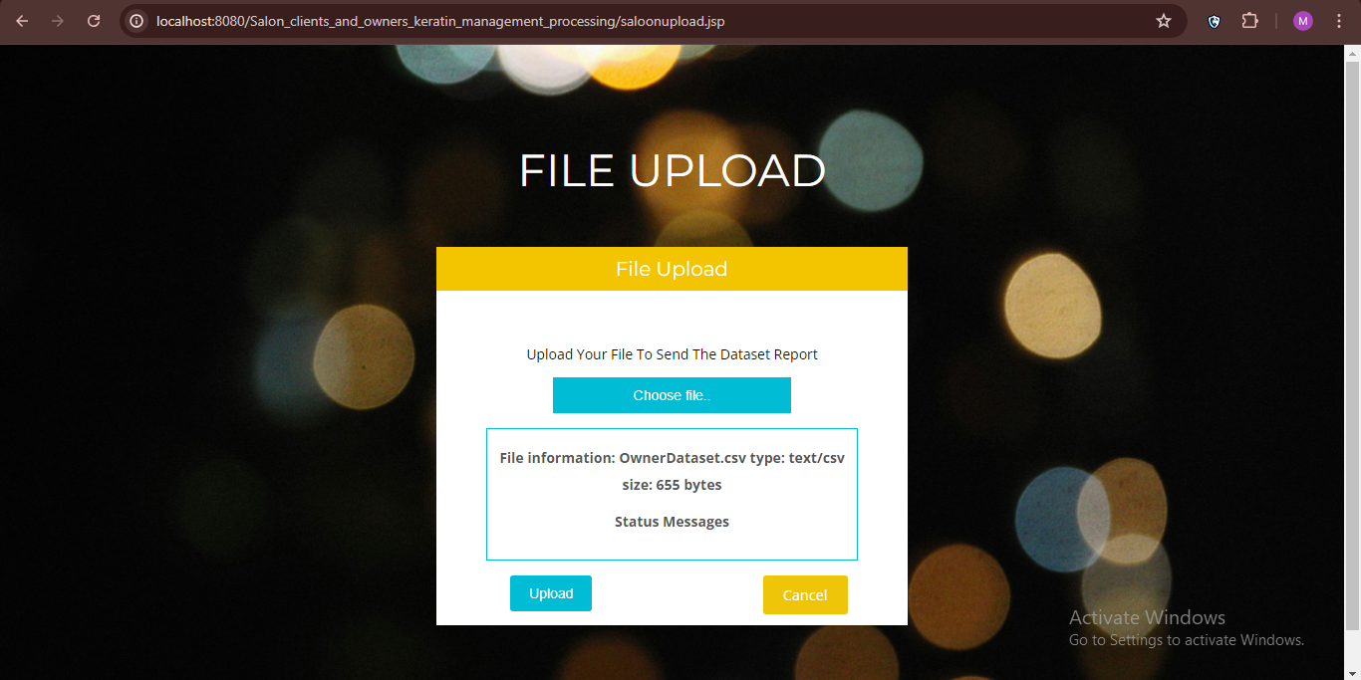

**Fig 1.11 dataset upload**

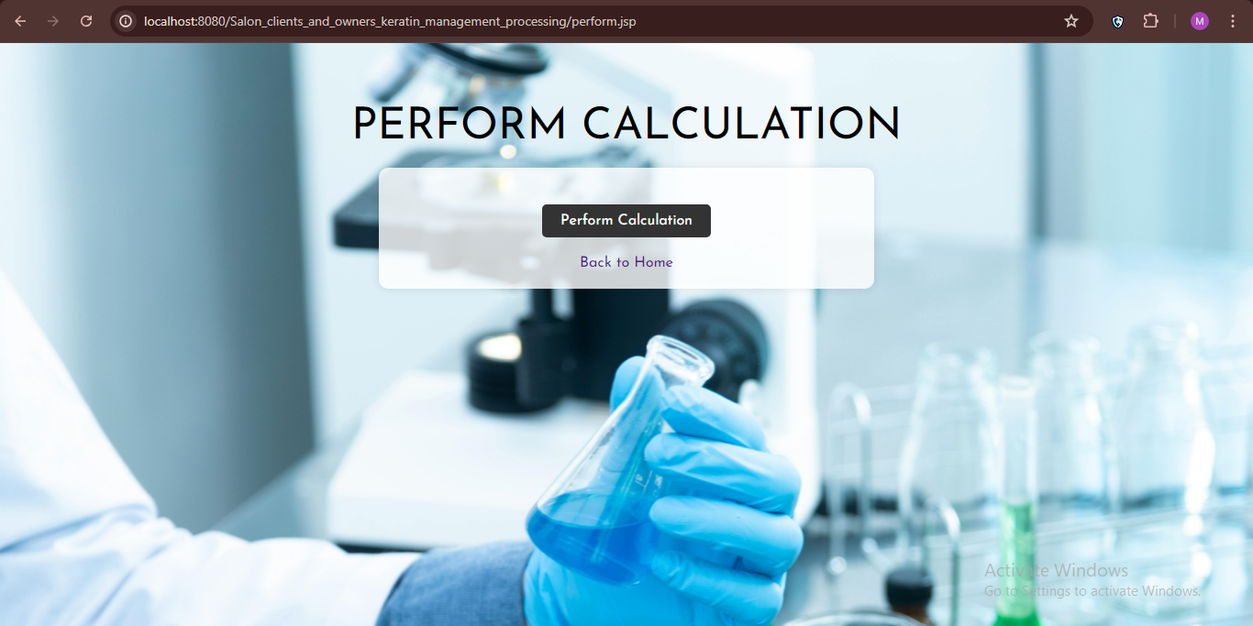

**Fig 1.12 calculation**

**66**

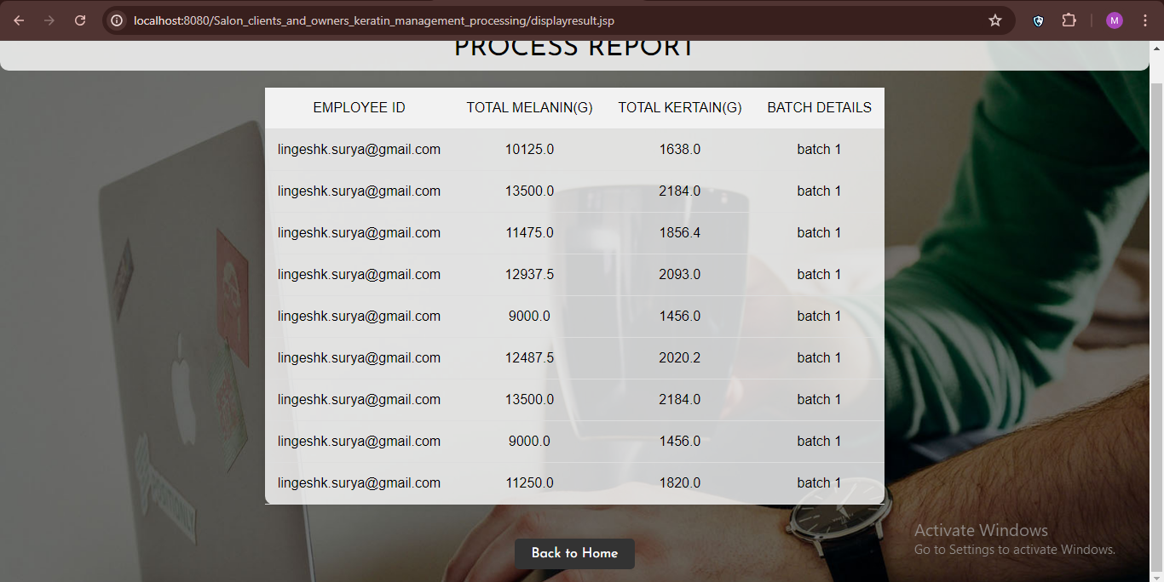

**Fig 1.13 process analysis**

**67**

**CONFERENCE CERTIFICATES**

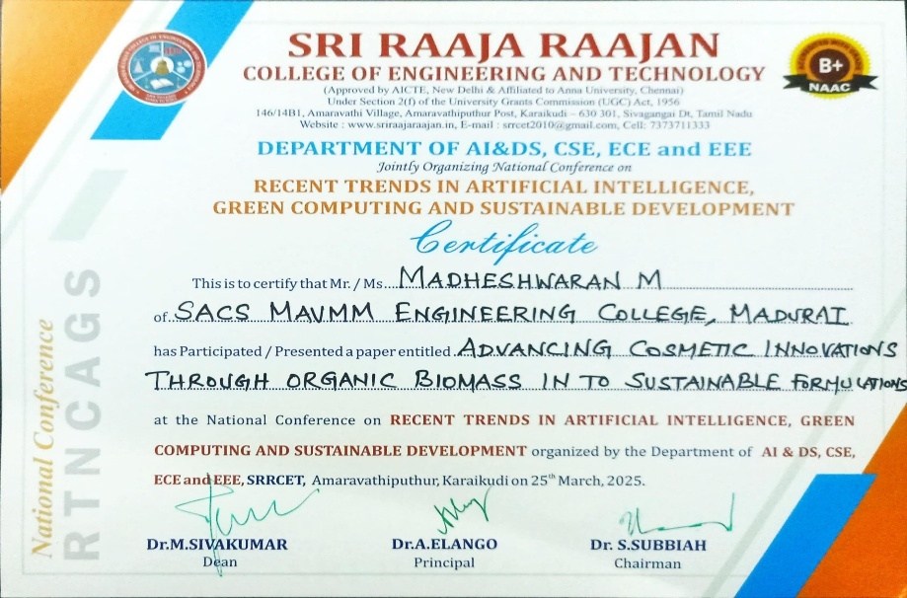

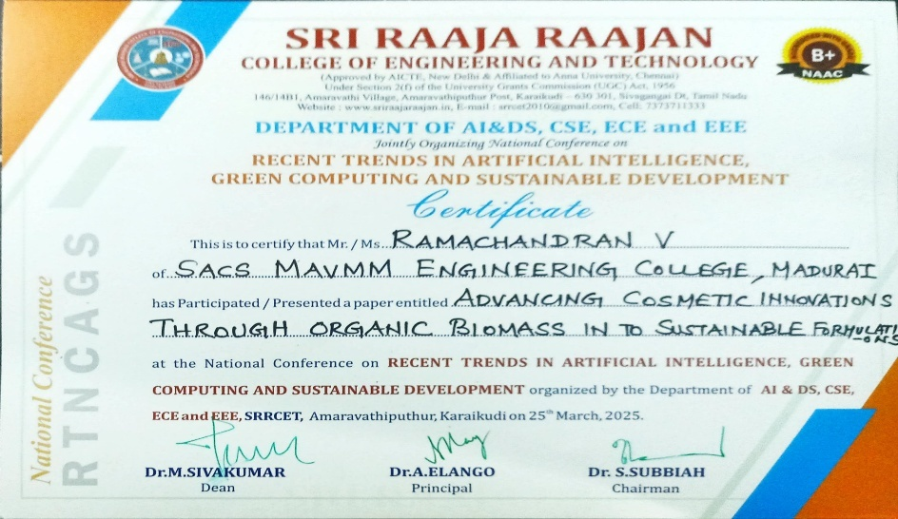

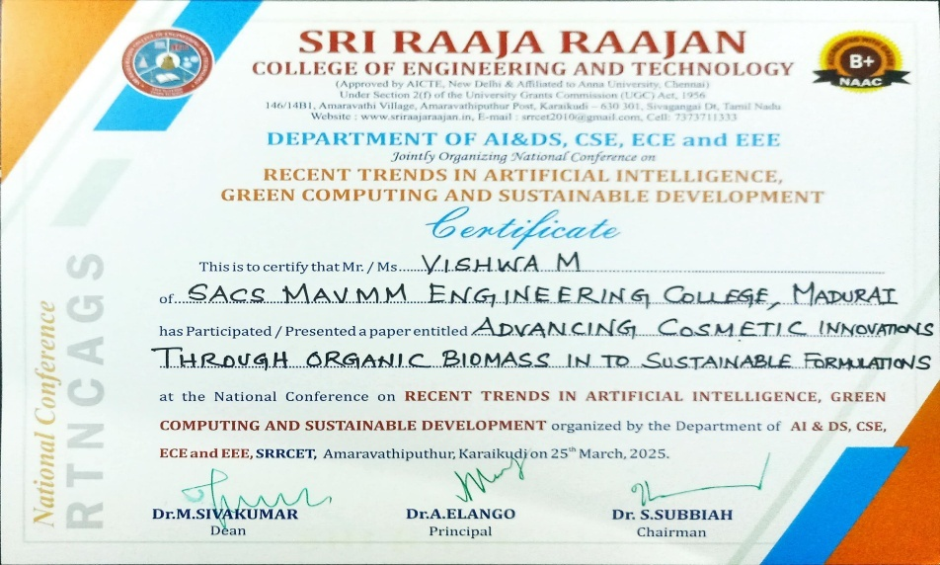

**68**

**REFERENCES**

[1] B. McMahan, E. Moore, D. Ramage, S. Hampson, and B. A. Y. Arcas, “Communication-efficient learning of deep networks from decentralized data,” in *Proc. Int. Conf. Artif. Intell. Stat.*, Apr. 2017, pp. 1273–1282.

[2] P. Kairouz et al., “Advances and open problems in federated learning, ”*Found. Trends Mach. Learn.*, vol. 14, no. 1, pp. 1–76, 2021.

[3] F. Sattler, S. Wiedemann, K.-R. Müller, and W. Samek, “Robust and communication-efficient federated learning from non-i.i.d. Data,” *IEEE* *Trans. Neural Netw. Learn. Syst.*, vol. 31, no. 9, pp. 3400–3413, Sep. 2020.

[4] F. Sattler, K.-R. Müller, and W. Samek, “Clustered federated learning: Model-agnostic distributed multitask optimization under privacy constraints,” *IEEE Trans. Neural Netw. Learn. Syst.*, vol. 32, no. 8, pp. 3710–3722, Aug. 2021. [5] N. Rieke et al., “The future of digital health with federated learning,” *NPJ Digit. Med.*, vol. 3, no. 1, pp. 1–7, 2020.

[6] J. Xu, B. S. Glicksberg, C. Su, P. Walker, J. Bian, and F. Wang, “Federated learning for healthcare informatics,” *J. Healthcare Informat.* *Res.*, vol. 5, no. 1, pp. 1–19, Mar. 2021.

T. S. Brisimi, R. Chen, T. Mela, A. Olshevsky, I. C. Paschalidis, and W. Shi, “Federated learning of predictive models from federated electronic health records,” *Int. J. Med. Inform.*, vol. 112, pp. 59–67, Jan. 2018.

[8] J. C. Jiang, B. Kantarci, S. Oktug, and T. Soyata, “Federated learning in smart city sensing: Challenges and opportunities,” *Sensors*, vol. 20, no. 21, p. 6230, Oct. 2020.

**69**